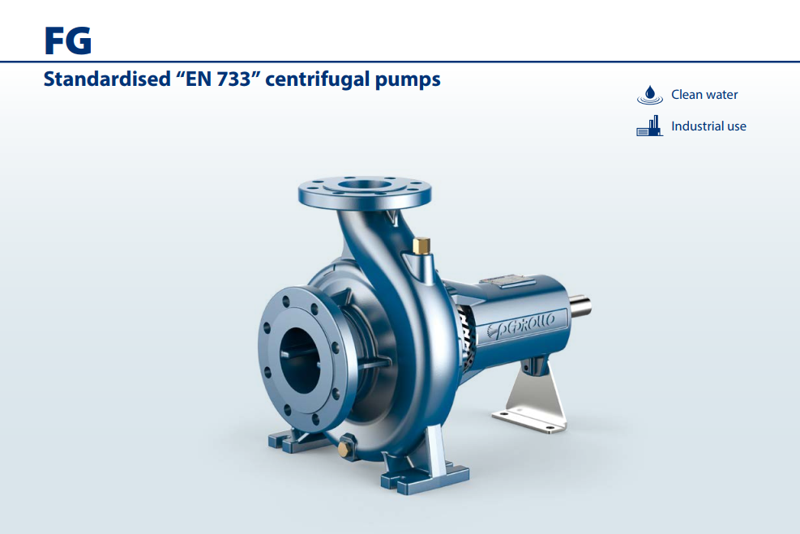
FG
Máy bơm ly tâm “EN 733” được tiêu chuẩn hóa

PHẠM VI HIẾU SUÂT

- Lưu lượng lên đến 6000 l/min (360 m³/h)
- Cột áp đến 98 m

LẮP ĐẶT VÀ SỬ DỤNG

Cấp nước • Bộ vệ sinh

Tăng áp • Bộ chữa cháy

Tưới tiêu • Ứng dụng CN

GIỚI HẠN ỨNG DỤNG

Lực hút áp suất nâng lên đến 7 m
- Nhiệt độ chất lỏng giữa -10 °C và +90 °C

Luân chuyển nước trong các đơn vị điều hòa không khí
• Ứng dụng NN

- Áp suất tối đa trong thân bơm 10 bar (PN10)

TIÊU CHUẨN THI CÔNG VÀ AN TOÀN
EN 733 QUY ĐỊNH EU N. 547/2012

TÙY CHỌN CÓ SẴN THEO YÊU CẦU

Bộ KIT mặt bích hoàn chỉnh với bu lông, đai ốc và vòng đệm

Phốt cơ khí đặc biệt

Máy bơm tương thích với động cơ 60 Hz

Khả năng tương thích với chất lỏng nóng hơn hoặc lạnh hơn

Khả năng tương thích với môi trường nóng hơn hoặc lạnh hơn

CHỨNG NHẬN
Công ty có hệ thống quản lý DNV đạt chứng
chỉ ISO 9001: CHẤT LƯỢNG

TỶ LỆ HIỆU SUẤT
n= 2900 min-1
 |  |  |  |  |  |  |  |  | 300 |  | 400 | 500 |  | 1000 |  | US g.p.m.
 | 30 |  | 40 | 50 |  | 100 |  | 200 |  | 300 |  | 400 | 500 |  | 1000 | Imp g.p.m.

30 40 50 100 200

120
110

100
90

80
70

60
50
Cột áp H (metres) 

40

feet 350
300
FG2
50/250
0/160
10

65/125

/125

50

5

40/12
0
80/16
65/160
/160
50
0
40/16
32/160

0/200
10
0

80/20

65/200

/200

50

40/200

32/200
0/250
10
0
80/25
65/250
40/250
32/250

250

200

150

30 100
90
25 80
70

20
60

15 50

40

10
9

8
100 150 200 300 400 500

1000 1500 2000 3000 4000 5000

30

l/min

6 7 8 9 10 20 30 40 50 60 70 80 90 100 150 200 250 300 350 m³/h
Lưu lượng Q 

DỮ LIỆU HIỆU SUẤT

MODEL | MOTOR PAIRING |  | PERFORMANCE  n= 2900 min-1
 | kW | HP | Q m³/h | H metres
FG2-32/160C | 1.5 | 2 | 6 – 21 | 24 – 14
FG2-32/160B | 2.2 | 3 | 6 – 24 | 30 – 17
FG2-32/160A | 3 | 4 | 6 – 27 | 37 – 24
FG2-32/200C | 4 | 5.5 | 6 – 27 | 44 – 31.5
FG2-32/200B | 5.5 | 7.5 | 6 – 30 | 51 – 36
FG2-32/200A | 7.5 | 10 | 6 – 30 | 57 – 44
FG2-32/200BH | 3 | 4 | 6 – 18 | 45 – 37
FG2-32/200AH | 4 | 5.5 | 6 – 19.2 | 55 – 44
FG2-32/250C | 9.2 | 12.5 | 6 – 27 | 75 – 60
FG2-32/250B | 11 | 15 | 6 – 30 | 87 – 70
FG2-32/250A | 15 | 20 | 6 – 30 | 97 – 80
FG2-40/125C | 1.1 | 1.5 | 6 – 33 | 16 – 6
FG2-40/125B | 1.5 | 2 | 6 – 36 | 20.5 – 9
FG2-40/125A | 2.2 | 3 | 6 – 42 | 26 – 10
FG2-40/160C | 2.2 | 3 | 6 – 36 | 27 – 14
FG2-40/160B | 3 | 4 | 6 – 36 | 32 – 20
FG2-40/160A | 4 | 5.5 | 6 – 42 | 38 – 20
FG2-40/200B | 5.5 | 7.5 | 6 – 42 | 47 – 28
FG2-40/200A | 7.5 | 10 | 6 – 42 | 55 – 41
FG2-40/250C | 9.2 | 12.5 | 6 – 42 | 64 – 47
FG2-40/250B | 11 | 15 | 6 – 42 | 71 – 55
FG2-40/250A | 15 | 20 | 6 – 42 | 88 – 72
FG2-50/125C | 2.2 | 3 | 18 – 72 | 17.5 – 6
FG2-50/125B | 3 | 4 | 18 – 72 | 20.7 – 9
FG2-50/125A | 4 | 5.5 | 18 – 72 | 23.5 – 13
FG2-50/160C | 4 | 5.5 | 18 – 60 | 27 – 16
FG2-50/160B | 5.5 | 7.5 | 18 – 66 | 32 – 21
FG2-50/160A | 7.5 | 10 | 18 – 66 | 37 – 27
FG2-50/200C | 11 | 15 | 24 – 102 | 44 – 30
FG2-50/200B | 15 | 20 | 24 – 102 | 52 – 38
FG2-50/200A | 18.5 | 25 | 24 – 108 | 61 – 45
FG2-50/200AR | 22 | 30 | 24 – 108 | 69 – 53
FG2-50/250D | 9.2 | 12.5 | 18 – 54 | 51 – 32
FG2-50/250C | 11 | 15 | 18 – 54 | 59 – 42
FG2-50/250B | 15 | 20 | 18 – 60 | 72 – 59
FG2-50/250A | 18.5 | 25 | 18 – 60 | 85 – 73
FG2-50/250AR | 22 | 30 | 18 – 60 | 95 – 83

MODEL | MOTOR PAIRING |  | PERFORMANCE  n= 2900 min-1
 | kW | HP | Q m³/h | H metres
FG2-65/125C | 4 | 5.5 | 36 – 108 | 16 – 11
FG2-65/125B | 5.5 | 7.5 | 36 – 120 | 18 – 13
FG2-65/125A | 7.5 | 10 | 36 – 132 | 23 – 18
FG2-65/160C | 9.2 | 12.5 | 36 – 132 | 32 – 22
FG2-65/160B | 11 | 15 | 36 – 144 | 36.5 – 23
FG2-65/160A | 15 | 20 | 36 – 144 | 40.5 – 28
FG2-65/200B | 15 | 20 | 12 – 144 | 44 – 30.5
FG2-65/200A | 18.5 | 25 | 12 – 150 | 50 – 36.5
FG2-65/200AR | 22 | 30 | 12 – 156 | 57 – 42
FG2-65/250C | 30 | 40 | 24 – 141 | 76 – 53
FG2-65/250B | 37 | 50 | 24 – 150 | 87 – 62
FG2-65/250A | 45 | 60 | 24 – 156 | 95 – 68
FG2-80/160D | 11 | 15 | 30 – 240 | 25 – 10
FG2-80/160C | 15 | 20 | 30 – 240 | 30 – 15
FG2-80/160B | 18.5 | 25 | 30 – 240 | 35 – 20
FG2-80/160A | 22 | 30 | 30 – 240 | 40 – 25
FG2-80/200B | 30 | 40 | 30 – 219 | 56 – 34.5
FG2-80/200A | 37 | 50 | 30 – 234 | 62 – 40
FG2-80/250B | 45 | 60 | 36 – 216 | 77 – 54
FG2-80/250A | 55 | 75 | 36 – 234 | 88.5 – 60
FG2-100/160C | 15 | 20 | 60 – 300 | 30 – 12
FG2-100/160B | 18.5 | 25 | 60 – 312 | 34 – 14.5
FG2-100/160A | 22 | 30 | 60 – 330 | 38 – 17.5
FG2-100/200C | 30 | 40 | 48 – 279 | 51 – 28
FG2-100/200B | 37 | 50 | 48 – 294 | 57 – 33
FG2-100/200A | 45 | 60 | 48 – 315 | 63 – 38
FG2-100/250B | 55 | 75 | 48 – 309 | 75 – 48
FG2-100/250A | 75 | 100 | 48 – 345 | 89 – 58

Q = Lưu lượng
H = Tổng áp
Tolerance of characteristic curves in compliance with EN ISO 9906 Grade 3B.

FG2-32/160
40
32/160A
FG2
51
55
57
58
32/160B
60
32/160C
η = 62%
60
58
Ø 169
57
55
51
Ø 155
Ø 143
MEI≥ 0.40

30
H (m)

20

103 6 9 12 15 18 21 24 27 30
3,0
Ø 169

C
B

A

2,5
Ø 155

P2 (kW)

2,0
Ø 143

1,5

1,03 6 9 12 15 18 21 24 27 30
6

Ø 169
NPSH (m)
4
2
03 6 9 12 15 18 21 24 27 30
Q (m³/h)

FG2-32/200
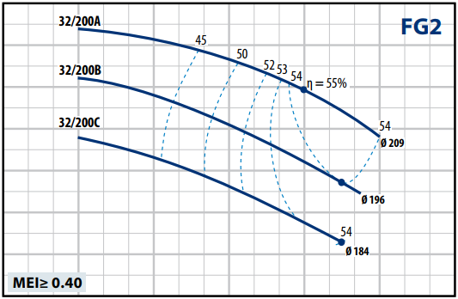
60

55

50

45
H (m)

40

35

30

250 6 12 18 24 30 36
7
Ø 209

Ø 196
Ø 184
C
B
A
6
5
P2 (kW)
4
3
20 6 12 18 24 30 36
8
Ø 209
NPSH (m)

4

00 6 12 18 24 30 36
Q (m³/h)

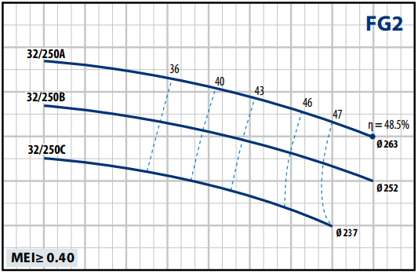
FG2-32/200H FG2-32/250

60
32/200AH
FG2
40
43
45
48
50
51.5
32/200BH
η = 53.5%

Ø 205
Ø 192

55

50

45
H (m)

40

35
MEI≥ 0.40
3 6 |  |  | 9 |  |  |  | 12 |  |  |  | 15 |  |  |  |  | 18 |  |  |  | 21

30
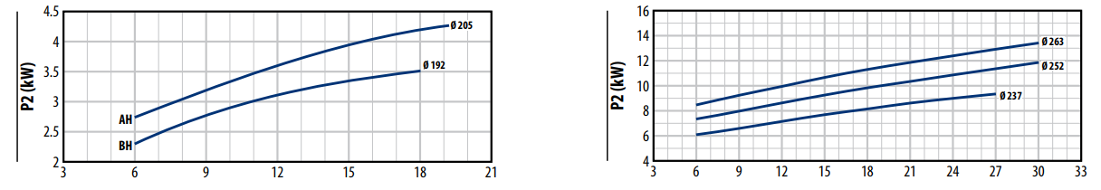

8
Ø 205

NPSH (m)

4

03 6 9 12 15 18 21

Q (m³/h)
110

100

90

80
H (m)

70

60

503 6 9 12 15 18 21 24 27 30 33

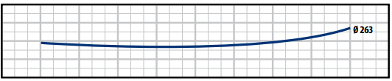
6
NPSH (m)
5
4
3
23 6 9 12 15 18 21 24 27 30 33
Q (m³/h)

ĐƯỜNG CONG ĐẶC TÍNH

FG2-40/125 FG2-40/160

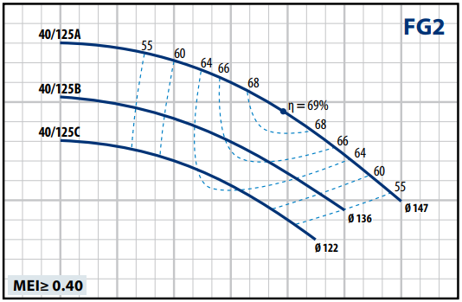
30

20
H (m)

10

0
2.5
2
1.5
P2 (kW)
1
0.5

0 6 12 18 24 30 36 42 48
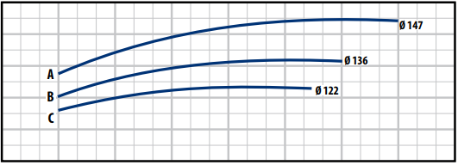

45

40
FG2
40/160A
55
60 63
40/160B
65
40/160C
η = 68%
65
63
60

Ø 157 Ø 169

Ø 148
MEI≥ 0.40

35

30
H (m)

25

20

15

100 6 12 18 24 30 36 42 48
4
Ø 169

Ø 148
C
B
A
Ø 157

3
P2 (kW)

2

00 6 12 18 24 30 36 42 48
6
Ø 147
NPSH (m)
5
4
3
2
10 6 12 18 24 30 36 42 48

Q (m³/h)
10 6 12 18 24 30 36 42 48
8
Ø 169

NPSH (m)

4

00 6 12 18 24 30 36 42 48
Q (m³/h)

FG2-40/200 FG2-40/250
60 100
40/200A
50
FG2
55 57
59
40/200B
63 η = 64%
63
Ø 205
59
57
55
54
Ø 188
MEI≥ 0.40
FG2
40/250A
42
46
48
50
40/250B
52 η = 53%
Ø 260
40/250C
Ø 233

Ø 223
MEI≥ 0.40

90
50
80

40 70
H (m)
H (m)

30

200 4
8
Ø 205
B
A
Ø 188
7
6
P2 (kW)
5
4
3
20 4
8
Ø 205
NPSH (m)

8 12 16 20

8 12 16 20

24 28

24 28

32 36

32 36

40 44 48

40 44 48
60

50

400
16
B C
A
Ø 223
Ø 233

14
12
P2 (kW)
10
8
6
40
8

NPSH (m)

4 8 12 16

4 8 12 16

20 24

20 24

28 32

28 32

36 40
Ø 260

36 40
Ø 260

44 48

44 48

4

00 4

8 12 16 20

24 28

32 36

40 44 48
4

00 4

8 12 16

20 24

28 32

36 40

44 48

Q (m³/h) Q (m³/h)

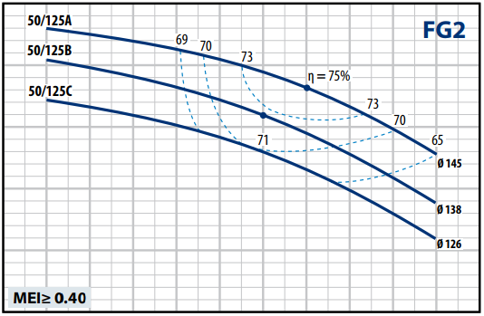
25 40
50/160A
62 64
FG2
67
70
50/160B
η = 71%
70
50/160C
71
67
Ø 171
64
Ø 161
62
Ø 152
MEI≥ 0.40

20 35
30
15
H (m)
H (m)
25
10
20

5 15

0
12 18 24
4
Ø 145
B
C

2
A

3.5
3
P2 (kW)
2.5
2
1.5
12 18 24
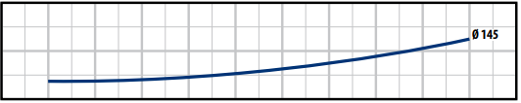
8
NPSH (m)

30 36 42 48 54 60 66

30 36 42 48 54 60 66

72 78

Ø 138

Ø 126

72 78
10
12 18 24
7.5

B C

A

6.5
5.5
P2 (kW)
4.5
3.5
2.5
12 18 24
8
Ø 171
NPSH (m)

30 36

30 36

42 48

42 48

54 60 66 72
Ø 171

Ø 161

Ø 152

54 60 66 72

4 4

0 0
18
24
30
36
42
48
54
60
66
72
78
12 12

18 24

30 36

42 48

54 60 66 72

Q (m³/h) Q (m³/h)

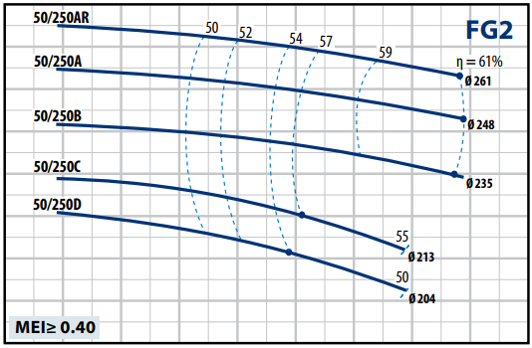
FG2-50/200 FG2-50/250

75
50/200AR
62
65
FG2
67 68
50/200A
η = 70%
50/200B
69
Ø 224
50/200C
Ø 215
68
67
Ø 200
MEI≥ 0.40
Ø 185

65

55
H (m)

45

35

25 108
24
36
48
60
72
84
96
12
25
Ø 224
A B C
AR
Ø 185
Ø 200
Ø 215

20
P2 (kW)

15

10

5 108
24
36
48
60
72
84
96
12
8
Ø 224
NPSH (m)

4

0 108
24
36
48
60
72
84
96
12

120

120

120
100
90
80
70
H (m)
60
50
40
30
20
12 18
25

Ø 248
Ø
D
Ø 204
C
213
A
B
AR
235
Ø
261
Ø

20
P2 (kW)

15

10

5
12 18
8

NPSH (m)

4

0
12 18

24 30

24 30

24 30

36 42

36 42

36 42

48 54

48 54

48 54

60 66

60 66
Ø 261

60 66

Q (m³/h) Q (m³/h)

ĐƯỜNG CONG ĐẶC TÍNH

FG2-65/125 FG2-65/160
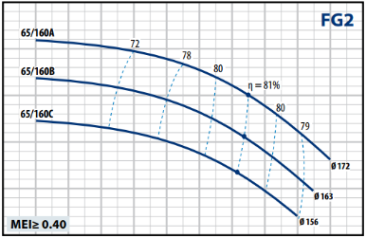
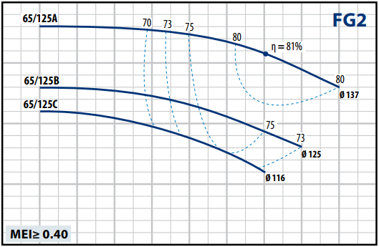
25 45

40
20

35
H (m)
H (m)
15
30

10
25

5
24 36 48
9

Ø 125

C
Ø 116
B
A

3

7
P2 (kW)

5

3
24 36 48
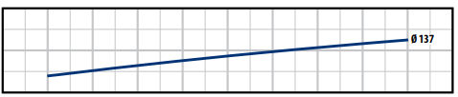
8
NPSH (m)

4

60 72 84

60 72 84

96 108

96 108

120

120

132

Ø 137

132

144

144
20
24 36 48
16
A
B
C

Ø 163

13
P2 (kW)

10

7

4
24 36 48
8
Ø 172
NPSH (m)

4

60 72

60 72

84 96

84 96

108

108

120

120

132

Ø 156

132

144
Ø 172

144

156

156

0 108
36
48
60
72
84
96
24

120

132

144
0 108

120

132

144

156

Q (m³/h) Q (m³/h)
36
48
60
72
84
96
24

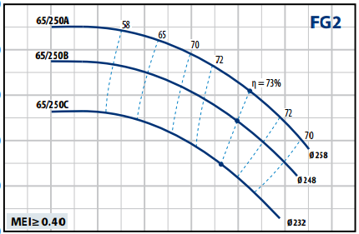
FG2-65/200 FG2-65/250

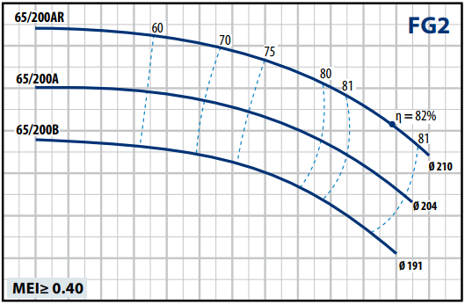
60

55

50

45
H (m)

40

35

30

250 12 24 36 48 60 72 84 96 108 120 132 144 156 168
25
Ø 210
Ø 191
B
A
AR

Ø 204

20
P2 (kW)

15

10

50 12 24 36 48 60 72 84 96 108 120 132 144 156 168
8
10
Ø 21
NPSH (m)

4
100

90

80
H (m)

70

60

500
50
Ø 258
Ø 248
Ø 232
B
A
C

40
P2 (kW)

30

20

100
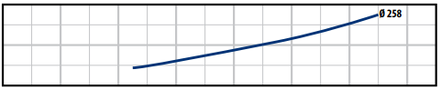
8
NPSH (m)

4

24 48 72

24 48 72

96 120

96 120

144

144

168

168

00 12 24 36 48 60 72 84 96 108 120 132 144 156 168

Q (m³/h)
00 24 48 72 96 120 144 168

Q (m³/h)

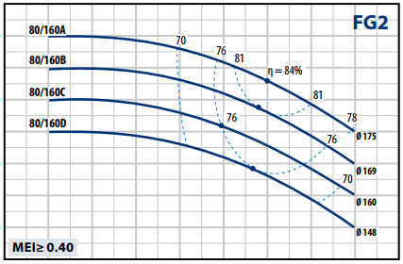
45
FG2
80/200A
60
68 70
72
80/200B
75
79
η = 82%

79
75
72
Ø 215
MEI≥ 0.40
Ø 206
40
35
30
25
H (m)
20
15
10
70

76 81
60

50
H (m)

40

50 30 60 90 120 150 180 210 240 270
25

Ø 175
Ø 169
Ø 160
A B C D
Ø 148

20
P2 (kW)

15

10

50 30 60 90 120 150 180 210 240 270
8
Ø 175
NPSH (m)

4

00 30 60 90 120 150 180 210 240 270

Q (m³/h)
300 50 100 150 200 250 300
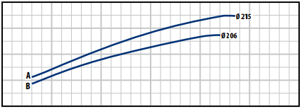
40

30
P2 (kW)

20

10

00 50 100 150 200 250 300
10
Ø 215
NPSH (m)

5

00 50 100 150 200 250 300
Q (m³/h)

FG2-80/250
100
80/250A
FG2
70
75
80/250B
76
η = 77%
75
71
69
Ø 253
Ø 238
MEI≥ 0.40

90

80

70
H (m)

60

50

400
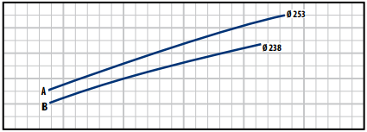
60
50
40
P2 (kW)
30
20
100
8

NPSH (m)

50 100

50 100

150

150

200

200

250

250

300

300

Ø 253

4

00 50

100

150

200

250

300

Q (m³/h)

ĐƯỜNG CONG ĐẶC TÍNH

FG2-100/160
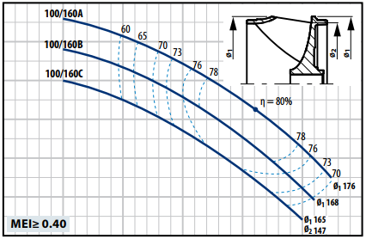
40

35

30

25
H (m)

20

15

100 60 120 180 240 300 360
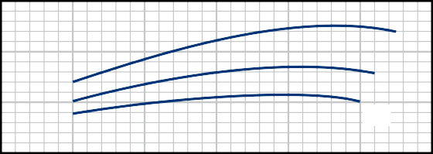25

Ø1 176

Ø1 168

Ø1 165
Ø2 147

20
P2 (kW)

15

100 60 120 180 240 300 360
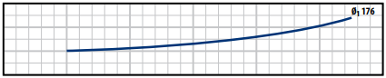
12
NPSH (m)
8
4
00 60 120 180 240 300 360

FG2-100/200
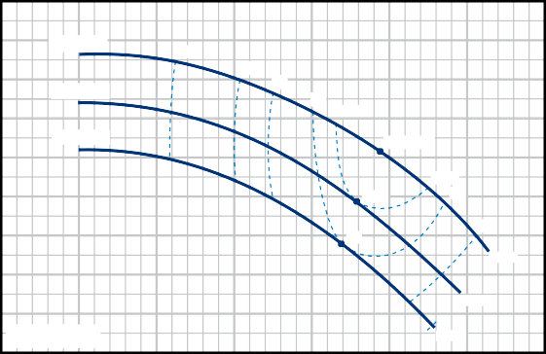70
100/200A
FG2
60
71
100/200B
75
79
80.5
100/200C
η = 81%
80.5
80.5 79
79 75
Ø 220
71
Ø 210
MEI≥ 0.40
Ø 201
65
60
55
50
H (m)
45
40
35
30
250 50 100 150 200
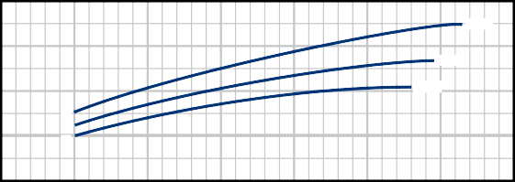50
Ø 220
Ø 210
Ø 201
A B
C

40
P2 (kW)

30

20

100 50 100 150 200
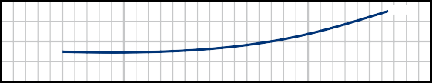8

NPSH (m)

4

00 50 100 150 200

n= 2900 min-1

250 300 350

250 300 350
Ø 220

250 300 350

Q (m³/h) Q (m³/h)

FG2-100/250
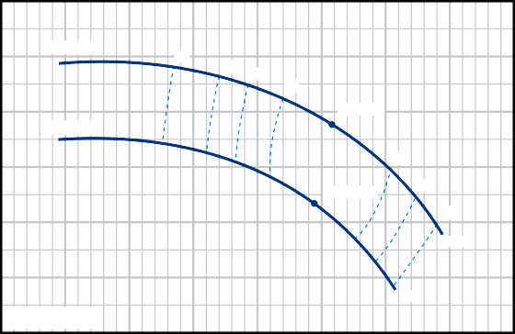100
FG2
100/250A
65
72 75
78
η = 80%
100/250B
78
η = 79.5%
75
71
Ø 256
Ø 236
MEI≥ 0.40

90

80

70
H (m)

60

50

400
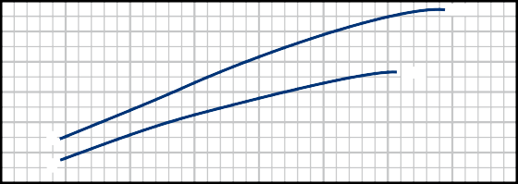80
Ø 256
A
B
36
Ø 23
70
60
P2 (kW)
50
40
30
200
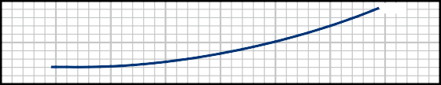10

NPSH (m)

5

00

50 100

50 100

50 100

150

150

150

200

200

200

250

250

250

300

300

300

350

350
Ø 256

350

400

400

400

Q (m³/h)

TỈ LỆ HIỆU SUẤT
15 20 25 30 35 40 45 50 100 200 300 400 500

US g.p.m.
n= 1450 min-1

30
15
20 25 30 35 40 45 50
100
200
300
400 500 Imp g.p.m.

FG4
32/250
40/250
50/250
65/250
80/250
100/250
32/200
40/200
50/200
65/200
80/200
100/200
32/160
80/160
40/160
50/160
65/160
65/125
100/160

20

15

10
Head H (metres) 

9
8

7
6

5

4

3

2

50 60

70 80 90100 150 200 300 400 500 1000 2000 3000
feet 90
80
70
60

50
45
40
35
30

25

20

15

10
9
8
7

l/min

3 4 5 6 7 8 9 10 20 30 40 50 60 70 80 90 100 150 200 m³/h
Flow rate Q 

DỮ LIỆU HIỆU SUẤT

MODEL | MOTOR PAIRING |  | PERFORMANCE  n= 1450 min-1
 | kW | HP | Q m³/h | H metres
FG4-32/160C | 0.25 | 0.33 | 3 – 10.5 | 6 – 3.5
FG4-32/160B | 0.37 | 0.5 | 3 – 12 | 7.5 – 4
FG4-32/160A | 0.37 | 0.5 | 3 – 13.5 | 9 – 6
FG4-32/200C | 0.55 | 0.75 | 3 – 13.5 | 11 – 8
FG4-32/200B | 0.75 | 1 | 3 – 15 | 12.5 – 9
FG4-32/200A | 1.1 | 1.5 | 3 – 15 | 14 – 11
FG4-32/200BH | 0.55 | 0.75 | 3 – 9 | 11 – 9
FG4-32/200AH | 0.55 | 0.75 | 3 – 9.6 | 13.8 – 11
FG4-32/250C | 1.1 | 1.5 | 3 – 13.2 | 18.4 – 15
FG4-32/250B | 1.5 | 2 | 3 – 15 | 21.7 – 17.4
FG4-32/250A | 2.2 | 3 | 3 – 16.2 | 23.8 – 18.7
FG4-40/160C | 0.37 | 0.5 | 3 – 18 | 6.5 – 3.5
FG4-40/160B | 0.37 | 0.5 | 3 – 18 | 8 – 5
FG4-40/160A | 0.55 | 0.75 | 3 – 21 | 9.5 – 5
FG4-40/200B | 0.75 | 1 | 3 – 21 | 11.5 – 7
FG4-40/200A | 1.1 | 1.5 | 3 – 21 | 13.5 – 10
FG4-40/250C | 1.1 | 1.5 | 3 – 21 | 16 – 11.5
FG4-40/250B | 1.5 | 2 | 3 – 21 | 17.5 – 13.5
FG4-40/250A | 2.2 | 3 | 3 – 21 | 22 – 18
FG4-50/125C | 0.37 | 0.5 | 9 – 36 | 4.3 – 1.5
FG4-50/125B | 0.55 | 0.75 | 9 – 36 | 5.1 – 2.3
FG4-50/125A | 0.55 | 0.75 | 9 – 36 | 5.8 – 3.2
FG4-50/160C | 0.55 | 0.75 | 9 – 30 | 7 – 4
FG4-50/160B | 0.75 | 1 | 9 – 33 | 8 – 5
FG4-50/160A | 1.1 | 1.5 | 9 – 33 | 9 – 7
FG4-50/200C | 1.5 | 2 | 12 – 51 | 11 – 7.5
FG4-50/200B | 2.2 | 3 | 12 – 51 | 13 – 9.5
FG4-50/200A | 2.2 | 3 | 12 – 54 | 15 – 11
FG4-50/200AR | 3 | 4 | 12 – 54 | 17 – 13
FG4-50/250D | 1.1 | 1.5 | 9 – 27 | 12.5 – 8
FG4-50/250C | 1.5 | 2 | 9 – 27 | 14.5 – 10.5
FG4-50/250B | 2.2 | 3 | 9 – 30 | 18 – 14.5
FG4-50/250A | 2.2 | 3 | 9 – 30 | 21 – 18
FG4-50/250AR | 3 | 4 | 9 – 30 | 24 – 21

MODEL | MOTOR PAIRING |  | PERFORMANCE  n= 1450 min-1
 | kW | HP | Q m³/h | H metres
FG4-65/125C | 0.55 | 0.75 | 18 – 54 | 4 – 2.7
FG4-65/125B | 0.75 | 1 | 18 – 60 | 4.5 – 3.2
FG4-65/125A | 1.1 | 1.5 | 18 – 66 | 5.8 – 4.5
FG4-65/160C | 1.1 | 1.5 | 18 – 66 | 8 – 5.5
FG4-65/160B | 1.5 | 2 | 18 – 72 | 9 – 5.5
FG4-65/160A | 2.2 | 3 | 18 – 72 | 10 – 7
FG4-65/200B | 2.2 | 3 | 6 – 72 | 10.5 – 7.3
FG4-65/200A | 2.2 | 3 | 6 – 75 | 12 – 8.5
FG4-65/200AR | 3 | 4 | 6 – 78 | 14 – 10
FG4-65/250C | 3 | 4 | 12 – 70.5 | 19 – 13
FG4-65/250B | 4 | 5.5 | 12 – 75 | 21.5 – 15.5
FG4-65/250A | 5.5 | 7.5 | 12 – 78 | 23.5 – 17
FG4-80/160D | 1.5 | 2 | 15 – 120 | 6 – 2.5
FG4-80/160C | 2.2 | 3 | 15 – 120 | 7.5 – 3.5
FG4-80/160B | 2.2 | 3 | 15 – 120 | 8.5 – 5
FG4-80/160A | 3 | 4 | 15 – 120 | 10 – 6
FG4-80/200B | 4 | 5.5 | 15 – 109.5 | 14 – 8.5
FG4-80/200A | 5.5 | 7.5 | 15 – 117 | 15.5 – 10
FG4-80/250B | 5.5 | 7.5 | 18 – 108 | 19 – 13.5
FG4-80/250A | 7.5 | 10 | 18 – 117 | 22 – 15
FG4-100/160C | 2.2 | 3 | 24 – 144 | 7.5 – 3
FG4-100/160B | 2.2 | 3 | 24 – 156 | 8.3 – 3.5
FG4-100/160A | 3 | 4 | 24 – 168 | 9.5 – 3.8
FG4-100/200C | 4 | 5.5 | 24 – 139.5 | 12.5 – 7
FG4-100/200B | 5.5 | 7.5 | 24 – 147 | 14 – 8
FG4-100/200A | 5.5 | 7.5 | 24 – 157.5 | 15.5 – 9.5
FG4-100/250B | 7.5 | 10 | 24 – 154.5 | 18.5 – 12
FG4-100/250A | 9.2 | 12.5 | 24 – 172.5 | 22 – 14.5

Q = Lưu lượng
H = Tổng áp
Tolerance of characteristic curves in compliance with EN ISO 9906 Grade 3B.

ĐƯỜNG CONG ĐẶC TÍNH

FG4-32/160
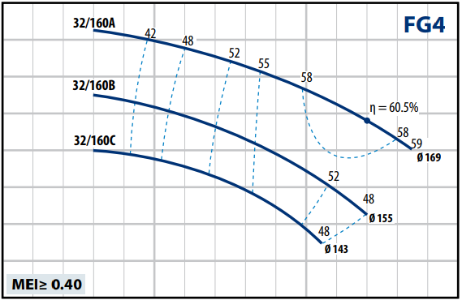
10
9
8
7
H (m)
6
5
4
3
20 5 10 15
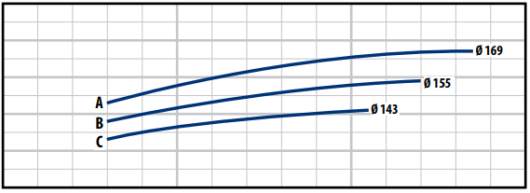
0.5
0.4
0.3
P2 (kW)
0.2
0.1
00 5 10 15
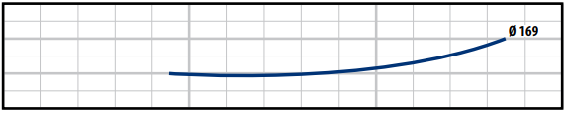
6
NPSH (m)
4
2
00 5 10 15

FG4-32/200
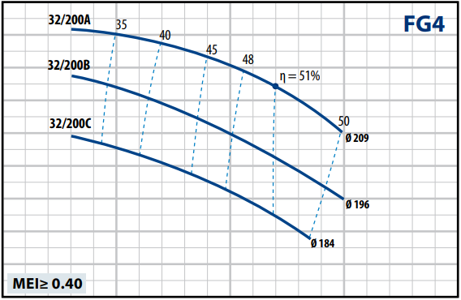
15
14
13
12
11
H (m)
10
9
8
7
60 5 10
1
Ø 209
Ø 184
C
B
A
Ø 196

0.5
P2 (kW)

00 5 10
8
NPSH (m)

4

00 5 10

n= 1450 min-1

15 20

15 20

15 20

Q (m³/h) Q (m³/h)

FG4-32/200H FG4-32/250
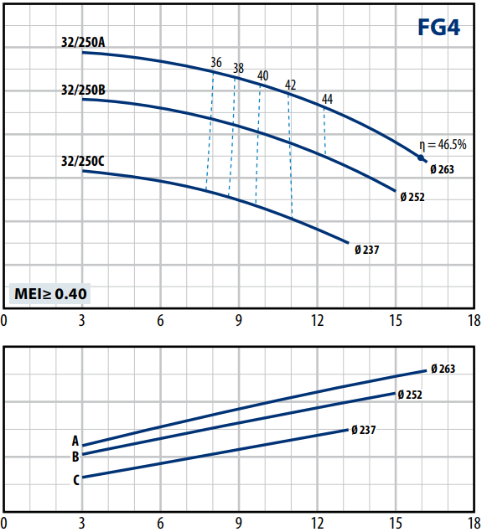
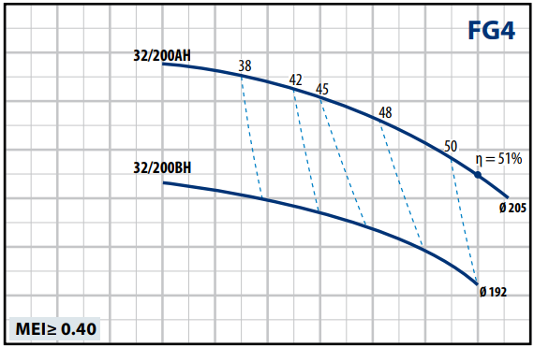
15 26

14 24

13 22

12 20
H (m)
H (m)

11 18

10

9

80
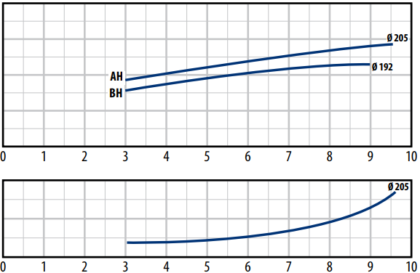
0.8

0.6
P2 (kW)

0.4

0.2

0
8
NPSH (m)

4

00

1 2 3 4 5 6 7 8

9 10

16
Ø205

14

12
2,0

1,5
P2 (kW)

1,0

0,5
5
Ø 263
NPSH (m)
4
3
2
1
00

3 6 9

12 15 18

Q (m³/h) Q (m³/h)

ĐƯỜNG CONG ĐẶC TÍNH

FG4-40/160
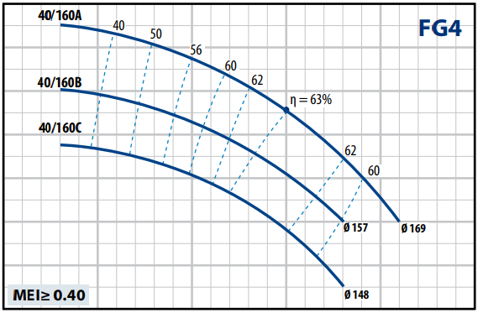
10

9

8

7
H (m)

6

5

4

30 5 10 15 20 25
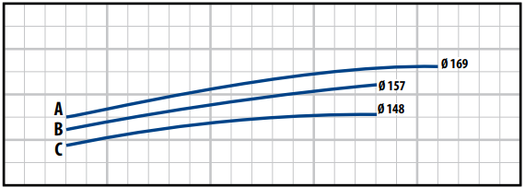
0.8

0.6
P2 (kW)

0.4

0.2

00 5 10 15 20 25
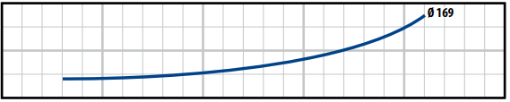
8
NPSH (m)

4

00 5 10 15 20 25

FG4-40/200
n= 1450 min-1
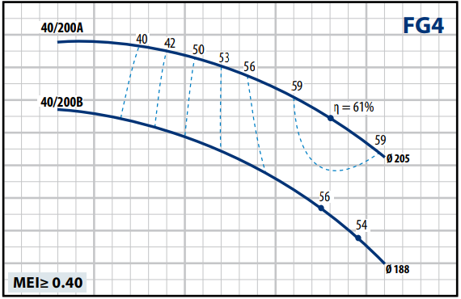
15
14
13
12
11
H (m)
10
9
8
7
60 5 10 15
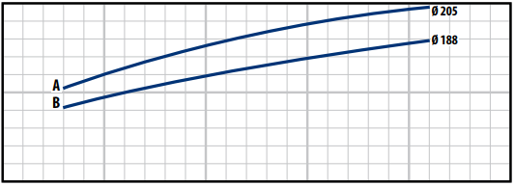
1

0.5
P2 (kW)

00 5 10 15
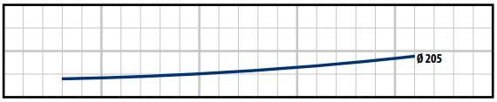
8
NPSH (m)

4

00 5 10 15

20 25

20 25

20 25

Q (m³/h) Q (m³/h)

FG4-40/250
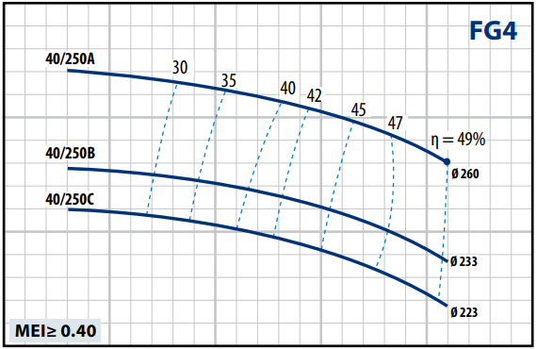
25

20
H (m)

15

100 5 10 15 20 25
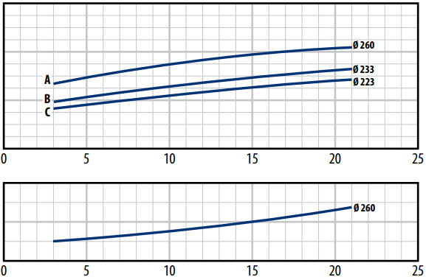
3

2
P2 (kW)

1

0
8
NPSH (m)

4

0

Q (m³/h)

ĐƯỜNG CONG ĐẶC TÍNH

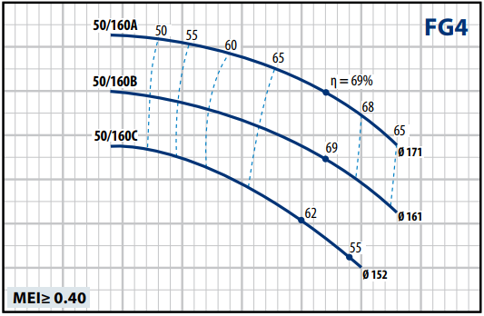
FG4-50/125 FG4-50/160

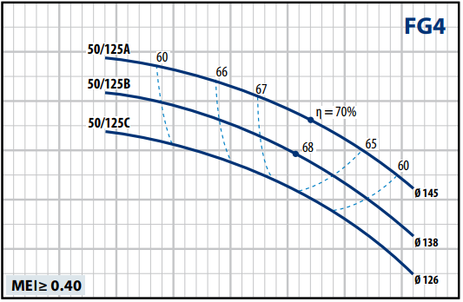
7

6

5

4
H (m)

3

2

10 5 10 15 20 25 30 35 40
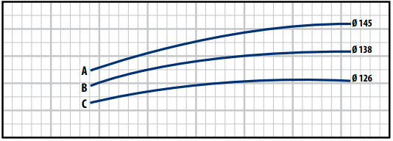
0.6
0.5
0.4
P2 (kW)
0.3
0.2
0.10 5 10 15 20 25 30 35 40
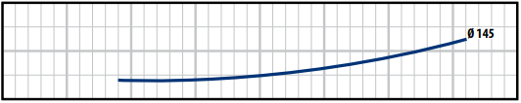
8
NPSH (m)

4

00 5 10 15 20 25 30 35 40

Q (m³/h)
10

9

8

7
H (m)

6

5

4

30 5 10 15 20 25 30 35 40
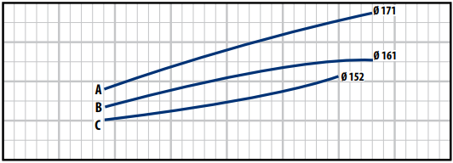
1
0.8
P2 (kW)

0.6

0.4

0.20 5 10 15 20 25 30 35 40
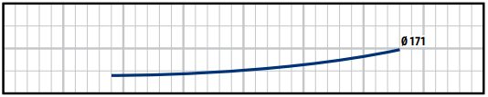
8
NPSH (m)

4

00 5 10 15 20 25 30 35 40
Q (m³/h)

FG4-50/200 FG4-50/250
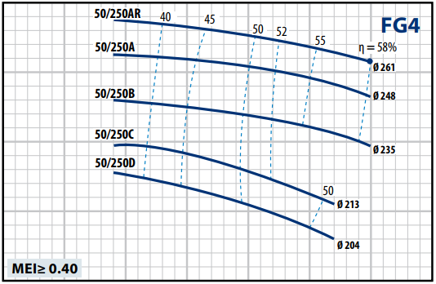
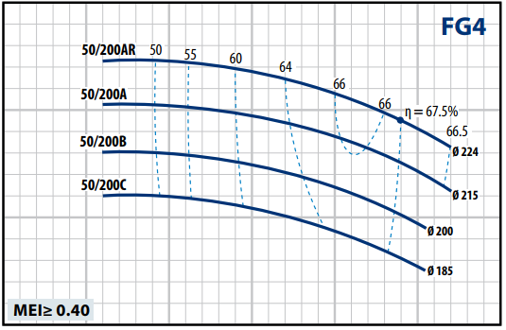
20 25

20
15

15
H (m)
H (m)

10
10

5
3.5

0 10
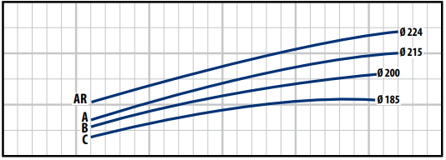

20 30 40

50 60

50
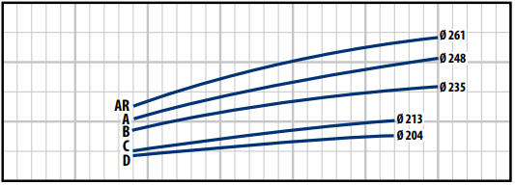
3.5

5 10 15 20 25

30 35

2.5 2.5
P2 (kW)
P2 (kW)

1.5

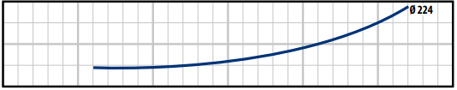
0.50 8
NPSH (m)
4

00

10 20 30 40

10 20 30 40

50 60

50 60
1.5

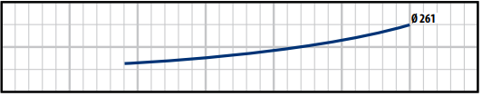
0.50 8
NPSH (m)
4

00

5 10 15 20 25

5 10 15 20 25

30 35

30 35

Q (m³/h) Q (m³/h)

ĐƯỜNG CONG ĐẶC TÍNH

FG4-65/125
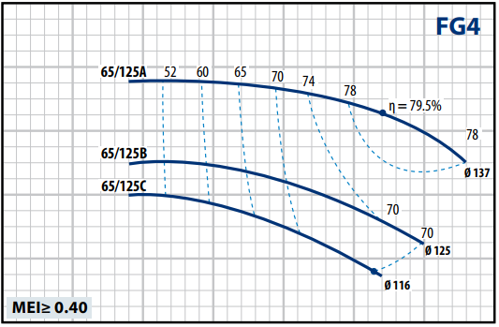
7

6

n= 1450 min-1

FG4-65/160
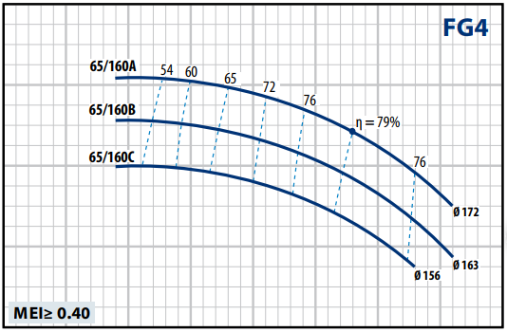
12

10

5
H (m)
H (m)
8
4

6
3

20 10 20 30 40 50 60 70
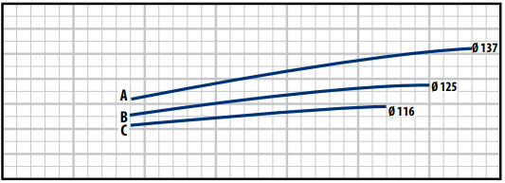
1.4
1.2
1
P2 (kW)
0.8
0.6
0.4
0.2
00 10 20 30 40 50 60 70
8

NPSH (m)
Ø 137

4

00 10 20 30 40 50 60 70

Q (m³/h)
40 10 20 30 40 50 60 70 80
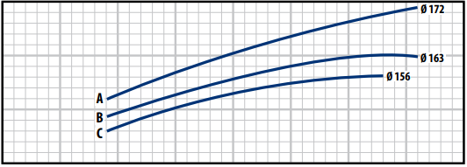
2

1.5
P2 (kW)

1

0.50 10 20 30 40 50 60 70 80
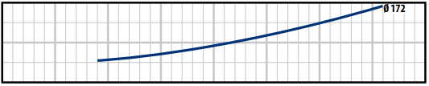
8
NPSH (m)

4

00 10 20 30 40 50 60 70 80
Q (m³/h)

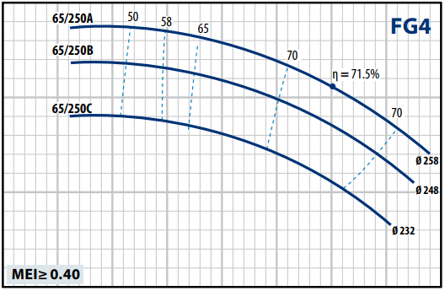
FG4-65/200 FG4-65/250

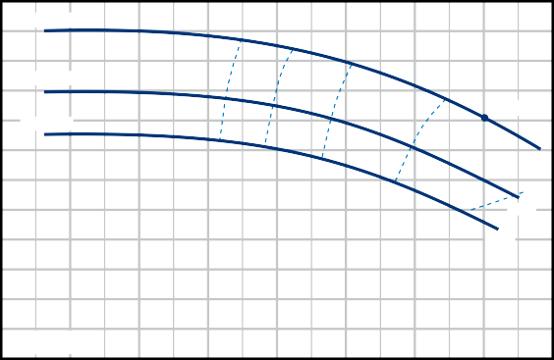15
65/200AR
65
70
FG4
75
65/200A
77
η = 78%
65/200B
Ø 210
74
Ø 204
Ø 191
MEI≥ 0.40
14
13
12
11
10
H (m)
9
8
7
6
5
4
30 10 20 30 40 50 60 70 80
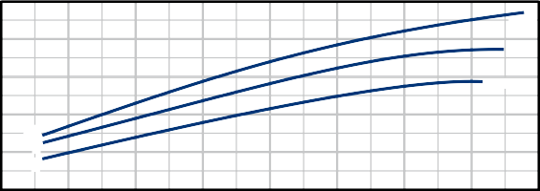3
Ø 210
B
A
AR

Ø 204
2.5
2
Ø 191

P2 (kW)
1.5
1
25

20
H (m)

15

100
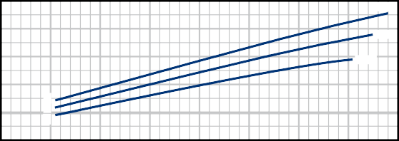6
Ø 258

Ø 248
Ø 232
B C
A
5
4
P2 (kW)
3
2

10 20

30 40

50 60

70 80

0.50 10 20 30 40 50 60 70 80
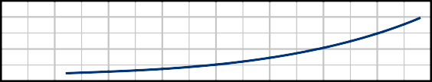8
Ø 210
NPSH (m)
4
00 10 20 30 40 50 60 70 80

Q (m³/h)
10 10 20 30 40 50 60 70 80
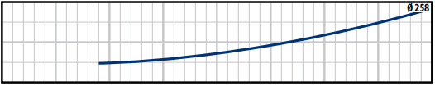
8
NPSH (m)

4

00 10 20 30 40 50 60 70 80
Q (m³/h)

ĐƯỜNG CONG ĐẶC TÍNH
n= 1450 min-1

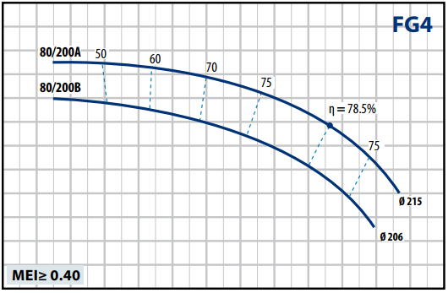
FG4-80/160 FG4-80/200

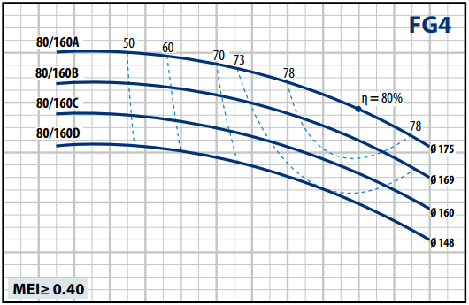
12

10

8

6
H (m)

4

2

00 10 20 30 40 50 60 70 80 90 100 110 120 130
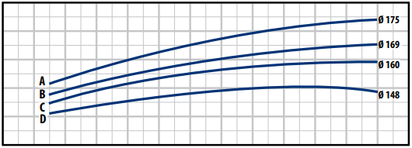
3
2.5
2
P2 (kW)
1.5
1
0.50 10 20 30 40 50 60 70 80 90 100 110 120 130
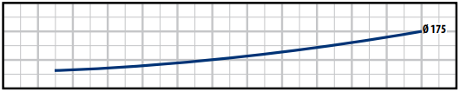
12
NPSH (m)
8
4
00 10 20 30 40 50 60 70 80 90 100 110 120 130

Q (m³/h)
18
17
16
15
14
13
H (m)
12
11
10
9
8
7
60 10 20 30 40 50 60 70 80 90 100 110 120 130
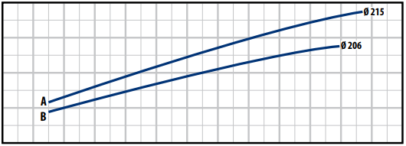
5

4
P2 (kW)

3

2

10 10 20 30 40 50 60 70 80 90 100 110 120 130
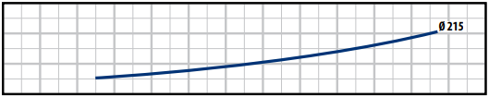
12
NPSH (m)
8
4
00 10 20 30 40 50 60 70 80 90 100 110 120 130
Q (m³/h)

FG4-80/250
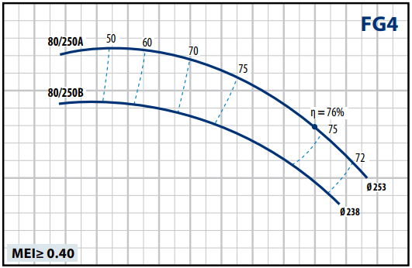
25

20
H (m)

15

100 10 20 30 40 50 60 70 80 90 100 110 120 130
8
Ø 238
A
B
Ø 253
7
6
P2 (kW)
5
4
3
20 10 20 30 40 50 60 70 80 90 100 110 120 130
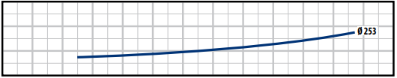
12
NPSH (m)
8
4
00 10 20 30 40 50 60 70 80 90 100 110 120 130
Q (m³/h)

ĐƯỜNG CONG ĐẶC TÍNH

FG4-100/160
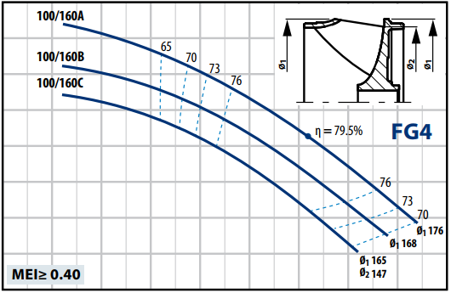
10
9

8

7
H (m)
6
5
4
3
20 20 40 60 80 100 120 140 160 180
3
Ø1 176
Ø1 168
Ø1 165
Ø2 147

2
P2 (kW)

10 20 40 60 80 100 120 140 160 180
8
176
Ø
NPSH (m)

4

00 20 40 60 80 100 120 140 160 180
Q (m³/h)

n= 1450 min-1

FG4-100/200
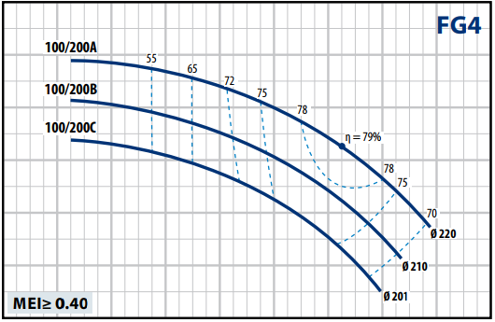
18

16

14

12
H (m)

10

8

60 20 40 60 80 100 120 140 160 180
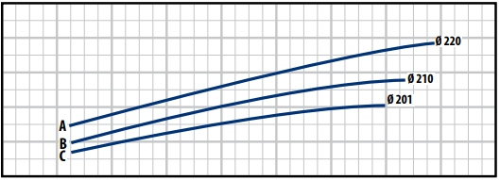
7
6
5
P2 (kW)
4
3
20 20 40 60 80 100 120 140 160 180
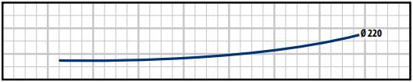
12
NPSH (m)
8
4
00 20 40 60 80 100 120 140 160 180
Q (m³/h)

FG4-100/250
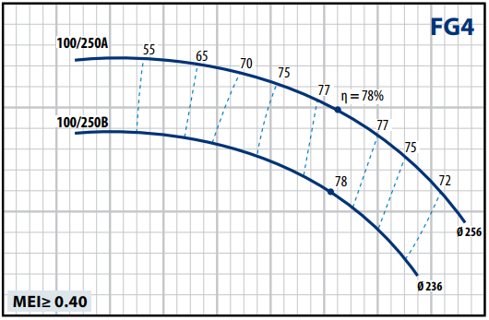
25

20
H (m)

15

100 20 40 60 80 100 120 140 160 180
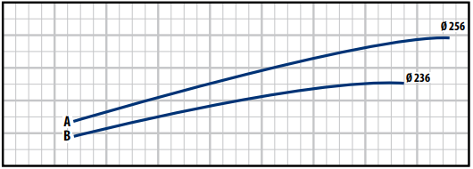
12
10
8
P2 (kW)
6
4
20 20 40 60 80 100 120 140 160 180
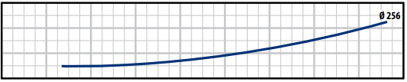
12
NPSH (m)
8
4
00 20 40 60 80 100 120 140 160 180
Q (m³/h)

h1

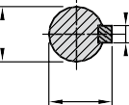KÍCH THƯỚC – TRỌNG LƯỢNG
e
DN1
d
d
c
h2

TRỤC mm
d | c | e
24 k6 | 8 | 27
32 k6 | 10 | 35

MODEL | KÍCH THƯỚC mm |  |  |  |  |  |  |  |  |  |  |  |  |  |  |  |  | kg
 | DN1 | DN2 | a | f | h1 | h2 | b | m1 | m2 | n1 | n2 | s1 | s2 | w | x | d | l
FG 32/160 | 50 | 32 | 80 | 360 | 132 | 160 | 55 | 96 | 71 | 240 | 190 | 14 | 14 | 260 | 100 | 24 | 50 | 33.0
FG 32/200 |  |  |  |  | 160 | 180 | 55 | 95 |  |  |  |  |  |  |  |  |  | 38.5
FG 32/200H |  |  |  |  | 160 | 180 | 55 |  |  |  |  |  |  |  |  |  |  | 36.8
FG 32/250 |  |  | 100 |  | 180 | 225 | 65 | 125 | 95 | 320 | 250 |  |  |  |  |  |  | 53.0
FG 40/125 | 65 | 40 | 80 |  | 112 | 140 | 50 | 100 | 70 | 210 | 160 |  |  |  |  |  |  | 34.0
FG 40/160 |  |  |  |  | 132 | 160 |  |  |  | 240 | 190 |  |  |  |  |  |  | 35.0
FG 40/200 |  |  | 100 |  | 160 | 180 | 55 |  |  | 265 | 212 |  |  |  |  |  |  | 40.0
FG 40/250 |  |  |  |  | 180 | 225 | 65 | 125 | 95 | 320 | 250 |  |  |  |  |  |  | 59.0
FG 50/125 | 65 | 50 |  |  | 132 | 160 | 50 | 100 | 70 | 240 | 190 |  |  |  |  |  |  | 33.0
FG 50/160 |  |  |  |  | 160 | 180 | 55 |  |  | 265 | 212 |  |  |  |  |  |  | 38.3
FG 50/200 |  |  |  |  | 160 | 200 | 50 |  |  |  |  |  |  |  |  |  |  | 50.3
FG 50/250 |  |  |  |  | 180 | 225 | 65 | 125 | 95 | 320 | 250 |  |  |  |  |  |  | 57.0
FG 65/125 | 80 | 65 |  |  | 160 | 180 | 65 |  |  | 280 | 212 |  |  |  |  |  |  | 45.0
FG 65/160 |  |  |  |  | 160 | 200 | 65 |  |  |  |  |  |  |  |  |  |  | 48.0
FG 65/200 |  |  |  |  | 180 | 225 | 65 |  |  | 320 | 250 |  |  |  | 140 |  |  | 55.0
FG 65/250 |  |  |  | 470 | 200 | 250 | 80 | 160 | 120 | 360 | 280 | 18 |  | 340 |  | 32 | 80 | 83.0
FG 80/160 | 100 | 80 | 125 | 360 | 180 | 225 | 65 | 125 | 95 | 320 | 250 | 14 |  | 260 |  | 24 | 50 | 53.0
FG 80/200 |  |  |  | 470 | 180 | 250 | 65 |  |  | 345 | 280 |  |  | 340 |  | 32 | 80 | 75.0
FG 80/250 |  |  |  |  | 200 | 280 | 80 | 160 | 120 | 400 | 315 | 18 |  |  |  |  |  | 93.0
FG 100/160 | 125 | 100 |  | 360 | 200 | 280 | 80 |  |  | 360 | 280 |  |  | 260 |  | 24 | 50 | 94.0
FG 100/200 |  |  |  | 470 | 200 | 280 | 80 |  |  |  |  |  |  | 340 |  | 32 | 80 | 87.0
FG 100/250 |  |  | 140 |  | 225 | 280 | 80 |  |  | 400 | 315 |  |  |  |  |  |  | 104.0

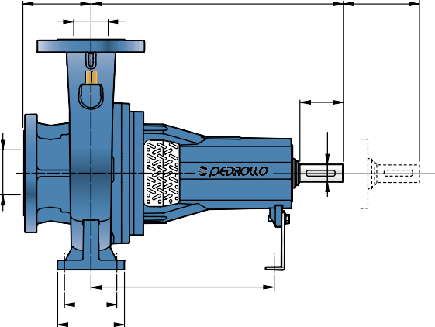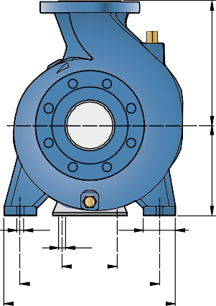CỔNG MẶT BÍCH MẶT BÍCH ĐỐI
a
f
x
DN2
l
w
m2
m1
S1
b
S2
110
n2
n1
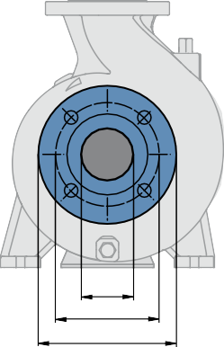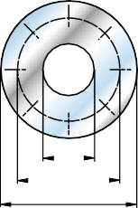(CÓ THỂ ĐẶT RIÊNG LẺ)
DN K D

F
K D
DN MẶT BÍCH  mm | D  mm | K  mm | HOLES
 |  |  | N° | Ø (mm)
32 | 140 | 100 | 4 | 18
40 | 150 | 110
50 | 165 | 125
65 | 185 | 145
80 | 200 | 160 | 8
100 | 220 | 180
125 | 250 | 210

DN MẶT BÍCH  mm | F  MẶT BÍCH ĐỐI | D  mm | K  mm | HOLES
 |  |  |  | N° | Ø (mm)
32 | 1¼" | 140 | 100 | 4 | 18
40 | 1½" | 150 | 110
50 | 2" | 165 | 125
65 | 2½" | 185 | 145
80 | 3" | 200 | 160 | 8
100 | 4" | 220 | 180
125 | 5" | 250 | 210

