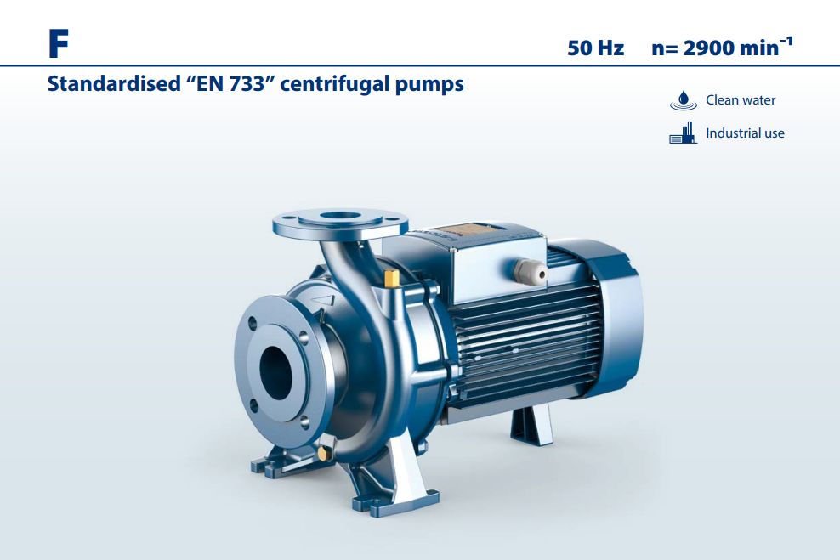**F 50 Hz n= 2900 min¯¹**

**Máy bơm ly tâm “EN 733” được tiêu chuẩn hóa**

## PHẠM VI HIỆU SUẤT

* Lưu lượng lên đến **6000 l/min** (360 m³/h)
* Cột áp đến **98 m**

## LẮP ĐẶT VÀ SỬ DỤNG

#### Cấp nước **•** Bộ vệ sinh

* Tăng áp **•** Bộ chữa cháy
* Tưới tiêu **•** Ứng dụng công nghiệp

## GIỚI HẠN ỨNG DỤNG

#### Lực hút manometric nâng đến **7 m**

* Luân chuyển nước trong các đơn vị điều hòa không khí

#### Ứng dụng nông nghiệp

* Nhiệt độ chất lỏng từ **-10 ° C** đến **+90 ° C**
* Nhiệt độ môi trường từ **-10 °C** đến **+40 °C**

#### Áp suất tối đa ở thân bơm **10 bar** (PN10)

* Dịch vụ liên tục **S1**

## TIÊU CHUẨN THI CÔNG VÀ AN TOÀN

Việc lắp đặt cần phải được thực hiện trong các khu vực kín thông gió tốt hoặc dù sao cũng được bảo vệ khỏi thời tiết xấu..

## TÙY CHỌN CÓ SẴN THEO YÊU CẦU

#### Bộ KIT mặt bích hoàn chỉnh với bu lông, đai ốc và vòng đệm

#### Phốt cơ khí đặc biệt

#### Khả năng tương thích với chất lỏng nóng hơn hoặc lạnh hơn

#### Khả năng tương thích với môi trường nóng hơn hoặc lạnh hơn

**EN 60335-1**

**IEC 60335-1**

### CEI 61-150

**EN 60034-1**

### IEC 60034-1

**CEI 2-3**

Kích thước thân bơm phù hợp với **QUY ĐỊNH EN 733 EU N. 547/2012**

## CHỨNG NHẬN

#### Công ty có hệ thống quản lý DNV đạt chứng chỉ ISO 9001: CHẤT LƯỢNG



50 Hz | F

159



## TỶ LỆ HIỆU SUẤT 50 Hz n= 2900 min-1

|  |  |  |  |  |  |  |  |  |  |  |  |  |  |  |  |  |
| --- | --- | --- | --- | --- | --- | --- | --- | --- | --- | --- | --- | --- | --- | --- | --- | --- |
|  | | | | | | | | | 300 |  | 400 | 500 |  | 1000 |  | US g.p.m. |
|  | 30 |  | 40 | 50 |  | 100 |  | 200 |  | 300 |  | 400 | 500 |  | 1000 | Imp g.p.m. |

30 40 50 100 200

### 110

**100**

### 90

**80**

### 70

**60**

### 50

**40**

**Cột áp H (metres)** 

feet



**F**

**50/250**

**32/250**

**40/250**

**65/250**

**80/250**

**100/250**

**32/200**

**40/200**

**50/200**

**65/200**

**80/200**

**100/200**

**32/160**

**50/160**

**65/160**

**80/160**

**40/160**

**100/160**

**50/125**

**65/125**

**40/125**

300

250

200

150

**30** 100

90

**25** 80

70

### 20

60

**15** 50

### 10

**9**

### 8 100 150 200 300 400 500

**1000 1500 2000 3000 4000 5000**

40

30

### l/min

6 7 8 9 10 20 30 40 50 60 70 80 90 100 150 200 250 300 350 m³/h

**Lưu lượng Q** 

## DỮ LIỆU HIỆU SUẤT 50 Hz n= 2900 min-1

|  |  |  |  |  |  |
| --- | --- | --- | --- | --- | --- |
| **MODEL** | **POWER (P2)** | | | **HIỆU SUẤT** | |
| **kW** | **HP** | ⯅ | **Q** l/min | **H** metres |
| **F 32/160C** | 1.5 | 2 | **IE3** | 100 – 350 | 24 – 14 |
| **F 32/160B** | 2.2 | 3 | 100 – 400 | 30 – 17 |
| **F 32/160A** | 3 | 4 | 100 – 450 | 37 – 24 |
| **F 32/200C** | 4 | 5.5 | 100 – 450 | 44 – 31.5 |
| **F 32/200B** | 5.5 | 7.5 | 100 – 500 | 51 – 36 |
| **F 32/200A** | 7.5 | 10 | 100 – 500 | 57 – 44 |
| **F 32/200BH** | 3 | 4 | 100 – 300 | 45 – 37 |
| **F 32/200AH** | 4 | 5.5 | 100 – 320 | 55 – 44 |
| **F 32/250C** | 9.2 | 12.5 | 100 – 450 | 75 – 60 |
| **F 32/250B** | 11 | 15 | 100 – 500 | 87 – 70 |
| **F 32/250A** | 15 | 20 | 100 – 500 | 97 – 80 |
| **F 40/125C** | 1.1 | 1.5 | **IE3** | 100 – 550 | 16 – 6 |
| **F 40/125B** | 1.5 | 2 | 100 – 600 | 20.5 – 9 |
| **F 40/125A** | 2.2 | 3 | 100 – 700 | 26 – 10 |
| **F 40/160C** | 2.2 | 3 | 100 – 600 | 27 – 14 |
| **F 40/160B** | 3 | 4 | 100 – 600 | 32 – 20 |
| **F 40/160A** | 4 | 5.5 | 100 – 700 | 38 – 20 |
| **F 40/200B** | 5.5 | 7.5 | 100 – 700 | 47 – 28 |
| **F 40/200A** | 7.5 | 10 | 100 – 700 | 55 – 41 |
| **F 40/250C** | 9.2 | 12.5 | 100 – 700 | 64 – 47 |
| **F 40/250B** | 11 | 15 | 100 – 700 | 71 – 55 |
| **F 40/250A** | 15 | 20 | 100 – 700 | 88 – 72 |
| **F 50/125C** | 2.2 | 3 | **IE3** | 300 – 1200 | 17.5 – 6 |
| **F 50/125B** | 3 | 4 | 300 – 1200 | 20.7 – 9 |
| **F 50/125A** | 4 | 5.5 | 300 – 1200 | 23.5 – 13 |
| **F 50/160C** | 4 | 5.5 | 300 – 1000 | 27 – 16 |
| **F 50/160B** | 5.5 | 7.5 | 300 – 1100 | 32 – 21 |
| **F 50/160A** | 7.5 | 10 | 300 – 1100 | 37 – 27 |
| **F 50/200C** | 11 | 15 | 400 – 1700 | 44 – 30 |
| **F 50/200B** | 15 | 20 | 400 – 1700 | 52 – 38 |
| **F 50/200A** | 18.5 | 25 | 400 – 1800 | 61 – 45 |
| **F 50/200AR** | 22 | 30 | 400 – 1800 | 69 – 53 |
| **F 50/250D** | 9.2 | 12.5 | 300 – 900 | 51 – 32 |
| **F 50/250C** | 11 | 15 | 300 – 900 | 59 – 42 |
| **F 50/250B** | 15 | 20 | 300 – 1000 | 72 – 59 |
| **F 50/250A** | 18.5 | 25 | 300 – 1000 | 85 – 73 |
| **F 50/250AR** | 22 | 30 | 300 – 1000 | 95 – 83 |

|  |  |  |  |  |  |
| --- | --- | --- | --- | --- | --- |
| **MODEL** | **POWER (P2)** | | | **HIỆU SUẤT** | |
| **kW** | **HP** | ⯅ | **Q** l/min | **H** metres |
| **F 65/125C** | 4 | 5.5 | **IE3** | 600 – 1800 | 16 – 11 |
| **F 65/125B** | 5.5 | 7.5 | 600 – 2000 | 18 – 13 |
| **F 65/125A** | 7.5 | 10 | 600 – 2200 | 23 – 18 |
| **F 65/160C** | 9.2 | 12.5 | 600 – 2200 | 32 – 22 |
| **F 65/160B** | 11 | 15 | 600 – 2400 | 36.5 – 23 |
| **F 65/160A** | 15 | 20 | 600 – 2400 | 40.5 – 28 |
| **F 65/200B** | 15 | 20 | 200 – 2400 | 44 – 30.5 |
| **F 65/200A** | 18.5 | 25 | 200 – 2500 | 50 – 36.5 |
| **F 65/200AR** | 22 | 30 | 200 – 2600 | 57 – 42 |
| **F 65/250C** | 30 | 40 | 400 – 2350 | 76 – 53 |
| **F 65/250B** | 37 | 50 | 400 – 2500 | 87 – 62 |
| **F 65/250A** | 45 | 60 | 400 – 2600 | 95 – 68 |
| **F 80/160D** | 11 | 15 | **IE3** | 500 – 4000 | 25 – 10 |
| **F 80/160C** | 15 | 20 | 500 – 4000 | 30 – 15 |
| **F 80/160B** | 18.5 | 25 | 500 – 4000 | 35 – 20 |
| **F 80/160A** | 22 | 30 | 500 – 4000 | 40 – 25 |
| **F 80/200B** | 30 | 40 | 500 – 3650 | 56 – 34.5 |
| **F 80/200A** | 37 | 50 | 500 – 3900 | 62 – 40 |
| **F 80/250B** | 45 | 60 | 600 – 3600 | 77 – 54 |
| **F 80/250A** | 55 | 75 | 600 – 3900 | 88.5 – 60 |
| **F 100/160C** | 15 | 20 | **IE3** | 1000 – 5000 | 30 – 12 |
| **F 100/160B** | 18.5 | 25 | 1000 – 5200 | 34 – 14.5 |
| **F 100/160A** | 22 | 30 | 1000 – 5500 | 38 – 17.5 |
| **F 100/200C** | 30 | 40 | 833 – 4650 | 51 – 28 |
| **F 100/200B** | 37 | 50 | 833 – 4900 | 57 – 33 |
| **F 100/200A** | 45 | 60 | 833 – 5250 | 63 – 38 |
| **F 100/250B** | 55 | 75 | 800 – 5150 | 75 – 48 |
| **F 100/250A** | 75 | 100 | 800 – 5750 | 89 – 58 |

**Q =** lưu lượng

**H** =Tổng áp

Tolerance of characteristic curves in compliance with EN ISO 9906 Grade 3B.

⯅ Lớp hiệu suất động cơ ba pha (IEC 60034-30-1)

# F32/160

## ĐƯỜNG CONG ĐẶC TÍNH VÀ DỮ LIỆU HIỆU SUẤT 50 Hz n= 2900 min-1 HS= 0 m

25 50 75 100

25 50 75 100

##### 40

**F32/160A**

**51**

**55**

**57**

**58**

**F32/160B**

**60**

η = **62%**

**60**

**F32/160C**

**58**

**57**

**55**

**51**

**MEI≥ 0.40**

**35**

US g.p.m.

Imp g.p.m.

feet 125

**H (feet)**

**30** 100

**Cột áp H (metres)** 

##### 25

75

##### 20

**15** 50

##### 10

**6**

**NPSH (metres)**

**NPSH (feet)**

15

##### 4

10

##### 2

5

**0** 0

##### 3.5 4

**A**

**B**

**C**

**P2 (HP)**

**2.5** 3

**Điện hấp thụ P2 (kW)**

2

##### 1.5

**0.5**

##### 50

**100**

##### 150

**200**

##### 250

**300**

##### 350

**400**

##### 450

1

##### l/min

5 10 15 20 25 m³/h

**Lưu lượng Q** 

|  |  |  |  |  |  |  |  |  |  |  |  |  |  |  |
| --- | --- | --- | --- | --- | --- | --- | --- | --- | --- | --- | --- | --- | --- | --- |
| **MODEL** | | **POWER (P2)** | | **Q** | m³/h | 0 | 6 | 9 | 12 | 15 | 18 | 21 | 24 | 27 |
| **Một pha** | **Ba pha** | **kW** | **HP** | l/min | **0** | **100** | **150** | **200** | **250** | **300** | **350** | **400** | **450** |
| **Fm 32/160C** | **F 32/160C** | 1.5 | 2 | **H** metres | | 25 | 24 | 23.5 | 22 | 20.5 | 18 | 14 |  |  |
| **Fm 32/160B** | **F 32/160B** | 2.2 | 3 | 31 | 30 | 29 | 28 | 26 | 23.5 | 20.5 | 17 |  |
| **–** | **F 32/160A** | 3 | 4 | 38 | 37 | 36 | 35 | 33.5 | 31.5 | 30 | 27.5 | 24 |

**Q** =Lưu lượng **H** = Tổng áp **HS** = Chiều sâu hút Tolerance of characteristic curves in compliance with EN ISO 9906 Grade 3B.

# F32/200

## ĐƯỜNG CONG ĐẶC TÍNH VÀ DỮ LIỆU HIỆU SUẤT 50 Hz n= 2900 min-1 HS= 0 m

0 50 100

0 50 100

##### 60

**F32/200A**

**45**

**50**

**F32/200B**

**52**

**53**

**54**

η = **55%**

**F32/200C**

**54**

**54**

**MEI≥ 0.40**

US g.p.m.

Imp g.p.m.

feet

##### 55

175

##### 50

150

**Cột áp H (metres)** 

##### 45

**H (feet)**

**40**

125

##### 35

**30** 100

##### 25

**8**

**NPSH (metres)**

##### 6

**4**

##### 2

**0**

##### 7

**A**

**B**

**C**

**Điện hấp thụ P2 (kW)**

**6**

##### 5

**4**

##### 3

**20 50**

##### 100

**150**

##### 200

**250**

##### 300

**350**

##### 400

**450**

##### 500

**550**

20

10

**NPSH (feet)**

0

9

**P2 (HP)**

8

7

6

5

4

3

##### l/min

0 5 10 15 20 25 30 m³/h

**Lưu lượng Q** 

|  |  |  |  |  |  |  |  |  |  |  |  |  |  |  |
| --- | --- | --- | --- | --- | --- | --- | --- | --- | --- | --- | --- | --- | --- | --- |
| **MODEL**  **Ba pha** | **POWER (P2)** | | **Q** | m³/h | 0 | 6 | 9 | 12 | 15 | 18 | 21 | 24 | 27 | 30 |
| **kW** | **HP** | l/min | **0** | **100** | **150** | **200** | **250** | **300** | **350** | **400** | **450** | **500** |
| **F 32/200C** | 4 | 5.5 | **H** metres | | 46 | 44 | 43 | 41.5 | 40 | 38 | 36 | 34 | 31.5 |  |
| **F 32/200B** | 5.5 | 7.5 | 52 | 51 | 50.5 | 49 | 47 | 45 | 43 | 41 | 38.5 | 36 |
| **F 32/200A** | 7.5 | 10 | 60 | 57 | 56.5 | 56 | 55 | 53.5 | 52 | 50 | 47 | 44 |

**Q** =Lưu lượng **H** = Tổng áp **HS** = Chiều sâu hút Tolerance of characteristic curves in compliance with EN ISO 9906 Grade 3B.

# F32/200H

## ĐƯỜNG CONG ĐẶC TÍNH VÀ DỮ LIỆU HIỆU SUẤT 50 Hz n= 2900 min-1 HS= 0 m

25 50 75

25 50

##### 60

US g.p.m.

Imp g.p.m.

feet

**H (feet)**

##### 55

175

##### 50

150

**Cột áp H (metres)** 

##### 45

**40**

125

##### 35

**30** 100

##### 8

**NPSH (metres)**

**NPSH (feet)**

**6** 20

##### 4

10

##### 2

**0** 0

##### 5

**AH**

**BH**

**P2 (HP)**

6

**Điện hấp thụ P2 (kW)**

##### 4

5

**3** 4

##### 2

**1**

##### 050

**100**

##### 150

**200**

##### 250

**300**

3

2

1

##### l/min 0

5 10 15 20 m³/h

**Lưu lượng Q** 

|  |  |  |  |  |  |  |  |  |  |  |  |
| --- | --- | --- | --- | --- | --- | --- | --- | --- | --- | --- | --- |
| **MODEL**  **Ba pha** | **POWER (P2)** | | **Q** | m³/h | 0 | 6 | 9 | 12 | 15 | 18 | 19.2 |
| **kW** | **HP** | l/min | **0** | **100** | **150** | **200** | **250** | **300** | **320** |
| **F 32/200BH** | 3 | 4 | **H** metres | | 47 | 45 | 44.5 | 43 | 40.5 | 37 |  |
| **F 32/200AH** | 4 | 5.5 | 57 | 55 | 54 | 52.5 | 50 | 46 | 44 |

**Q** =Lưu lượng **H** = Tổng áp **HS** = Chiều sâu hút Tolerance of characteristic curves in compliance with EN ISO 9906 Grade 3B.

# F32/250

## ĐƯỜNG CONG ĐẶC TÍNH VÀ DỮ LIỆU HIỆU SUẤT 50 Hz n= 2900 min-1 HS= 0 m

##### 110

0 25 50 75 100 125

0 25 50 75 100

US g.p.m.

Imp g.p.m.

feet 350

##### 100

325

300

##### 90

**Cột áp H (metres)** 

275

**H (feet)**

##### 80

250

##### 70

225

**60** 200

##### 50

**6**

**NPSH (metres)**

##### 5

**4**

##### 3

**2**

##### 16

**Điện hấp thụ P2 (kW)**

**14**

##### 12

**10**

##### 8

**6**

##### 450 100

**150**

##### 200

**250**

##### 300

**350**

##### 400

**450**

##### 500

175

15

**NPSH (feet)**

10

20

**A**

**B**

**C**

**P2 (HP)**

15

10

5

##### l/min 0

5 10 15 20 25 30 m³/h

**Lưu lượng Q** 

|  |  |  |  |  |  |  |  |  |  |  |  |  |  |  |
| --- | --- | --- | --- | --- | --- | --- | --- | --- | --- | --- | --- | --- | --- | --- |
| **MODEL**  **Ba pha** | **POWER (P2)** | | **Q** | m³/h | 0 | 6 | 9 | 12 | 15 | 18 | 21 | 24 | 27 | 30 |
| **kW** | **HP** | l/min | **0** | **100** | **150** | **200** | **250** | **300** | **350** | **400** | **450** | **500** |
| **F 32/250C** | 9.2 | 12.5 | **H** metres | | 76 | 75 | 74.5 | 73 | 71.5 | 69.5 | 67 | 64 | 60 |  |
| **F 32/250B** | 11 | 15 | 88 | 87 | 86 | 85 | 83 | 81 | 79 | 76.5 | 73.5 | 70 |
| **F 32/250A** | 15 | 20 | 98 | 97 | 96 | 95 | 93 | 91 | 89 | 86.5 | 83.5 | 80 |

**Q** =Lưu lượng **H** = Tổng áp **HS** = Chiều sâu hút Tolerance of characteristic curves in compliance with EN ISO 9906 Grade 3B.

# F40/125

## ĐƯỜNG CONG ĐẶC TÍNH VÀ DỮ LIỆU HIỆU SUẤT 50 Hz n= 2900 min-1 HS= 0 m

0 50 100 150

0 50 100 150

##### 30

US g.p.m.

Imp g.p.m.

feet

**H (feet)**

90

**25** 80

70

##### 20

**Cột áp H (metres)** 

60

**15** 50

40

##### 10

30

20

##### 5

**0**

##### 6

**NPSH (metres)**

**5**

##### 4

**3**

##### 2

**1**

##### 2.5

**Điện hấp thụ P2 (kW)**

**2**

##### 1.5

**1,0**

##### 0.5

**00**

##### 100

**200**

##### 300

**400**

##### 500

**600**

##### 700

10

0

**NPSH (feet)**

15

10

5

3

**A**

**B**

**C**

**P2 (HP)**

2.5

2

1.5

1

0.5

##### l/min 0

0 5 10 15 20 25 30 35 40 45 m³/h

**Lưu lượng Q** 

|  |  |  |  |  |  |  |  |  |  |  |  |  |  |  |  |
| --- | --- | --- | --- | --- | --- | --- | --- | --- | --- | --- | --- | --- | --- | --- | --- |
| **MODEL** | | **POWER (P2)** | | **Q** | m³/h | 0 | 6 | 12 | 18 | 24 | 30 | 33 | 36 | 39 | 42 |
| **Một pha** | **Ba pha** | **kW** | **HP** | l/min | **0** | **100** | **200** | **300** | **400** | **500** | **550** | **600** | **650** | **700** |
| **Fm 40/125C** | **F 40/125C** | 1.1 | 1.5 | **H** metres | | 16 | 16 | 15.5 | 14 | 11.5 | 8 | 6 |  |  |  |
| **Fm 40/125B** | **F 40/125B** | 1.5 | 2 | 20.5 | 20.5 | 19.8 | 18.5 | 16 | 12.8 | 11 | 9 |  |  |
| **–** | **F 40/125A** | 2.2 | 3 | 26 | 26 | 25.5 | 24 | 22 | 18.5 | 17 | 14.5 | 12.5 | 10 |

**Q** =Lưu lượng **H** = Tổng áp **HS** = Chiều sâu hút Tolerance of characteristic curves in compliance with EN ISO 9906 Grade 3B.

# F40/160

## ĐƯỜNG CONG ĐẶC TÍNH VÀ DỮ LIỆU HIỆU SUẤT 50 Hz n= 2900 min-1 HS= 0 m

0 50 100 150

0 50 100 150

##### 45

**F40/160A**

**55**

**60**

**63**

**F40/160B**

**65**

η = **68%**

**F40/160C**

**65**

**63**

**60**

**MEI≥ 0.40**

US g.p.m.

Imp g.p.m.

feet

##### 40

125

##### 35

**30** 100

**Cột áp H (metres)** 

**H (feet)**

##### 25

75

##### 20

**15** 50

##### 10

**8**

**NPSH (metres)**

##### 6

**4**

##### 2

**0**

##### 5

**A**

**B**

**C**

**Điện hấp thụ P2 (kW)**

**4**

##### 3

**2**

##### 1

**00 100 200 300 400 500 600 700**

20

10

**NPSH (feet)**

0

**P2 (HP)**

6

5

4

3

2

1

##### l/min 0

0 5 10 15 20 25 30 35 40 45 m³/h

**Lưu lượng Q** 

|  |  |  |  |  |  |  |  |  |  |  |  |  |  |  |  |
| --- | --- | --- | --- | --- | --- | --- | --- | --- | --- | --- | --- | --- | --- | --- | --- |
| **MODEL** | | **POWER (P2)** | | **Q** | m³/h | 0 | 6 | 9 | 12 | 15 | 18 | 24 | 30 | 36 | 42 |
| **Một pha** | **Ba pha** | **kW** | **HP** | l/min | **0** | **100** | **150** | **200** | **250** | **300** | **400** | **500** | **600** | **700** |
| **Fm 40/160C** | **F 40/160C** | 2.2 | 3 | **H** metres | | 27 | 27 | 26.5 | 26 | 25.5 | 25 | 22.5 | 19 | 14 |  |
| **–** | **F 40/160B** | 3 | 4 | 32 | 32 | 31.5 | 31 | 30.5 | 30 | 27.5 | 24 | 20 |  |
| **–** | **F 40/160A** | 4 | 5.5 | 38 | 38 | 37.8 | 37 | 36.5 | 36 | 33.5 | 30 | 26 | 20 |

**Q** =Lưu lượng **H** = Tổng áp **HS** = Chiều sâu hút Tolerance of characteristic curves in compliance with EN ISO 9906 Grade 3B.

# F40/200

## ĐƯỜNG CONG ĐẶC TÍNH VÀ DỮ LIỆU HIỆU SUẤT 50 Hz n= 2900 min-1 HS= 0 m

0 50 100 150

0 50 100 150

##### 60

US g.p.m.

Imp g.p.m.

feet

**H (feet)**

##### 55

200

##### 50

**45**

**Cột áp H (metres)** 

**40** 150

##### 35

**30**

100

##### 25

**20**

##### 6

**NPSH (metres)**

**NPSH (feet)**

15

##### 4

10

##### 2

5

**0** 0

##### 8

**A**

**B**

**P2 (HP)**

10

**Điện hấp thụ P2 (kW)**

##### 7

**6** 8

##### 5

6

##### 4

**3**

##### 20 100

**200**

##### 300

**400**

##### 500

**600**

##### 700

4

##### l/min

0 5 10 15 20 25 30 35 40 45 m³/h

**Lưu lượng Q** 

|  |  |  |  |  |  |  |  |  |  |  |  |  |  |  |
| --- | --- | --- | --- | --- | --- | --- | --- | --- | --- | --- | --- | --- | --- | --- |
| **MODEL**  **Ba pha** | **POWER (P2)** | | **Q** | m³/h | 0 | 6 | 9 | 12 | 15 | 18 | 24 | 30 | 36 | 42 |
| **kW** | **HP** | l/min | **0** | **100** | **150** | **200** | **250** | **300** | **400** | **500** | **600** | **700** |
| **F 40/200B** | 5.5 | 7.5 | **H** metres | | 48 | 47 | 46.5 | 46 | 45.5 | 44.5 | 42 | 38 | 34 | 28 |
| **F 40/200A** | 7.5 | 10 | 56 | 55 | 55 | 55 | 54.5 | 54 | 52.5 | 49.5 | 46 | 41 |

**Q** =Lưu lượng **H** = Tổng áp **HS** = Chiều sâu hút Tolerance of characteristic curves in compliance with EN ISO 9906 Grade 3B.

# F40/250

## ĐƯỜNG CONG ĐẶC TÍNH VÀ DỮ LIỆU HIỆU SUẤT 50 Hz n= 2900 min-1 HS= 0 m

##### 100

0 50 100 150

0 50 100 150

**F40/250A**

**42**

**46**

**48**

**50**

**52**

**F40/250B**

η = **53%**

**F40/250C**

**MEI≥ 0.40**

US g.p.m.

Imp g.p.m.

feet

300

##### 90

**80**

**Cột áp H (metres)** 

250

##### 70

**H (feet)**

**60** 200

##### 50

150

##### 40

**8**

**NPSH (metres)**

**6** 20

**NPSH (feet)**

##### 4

10

##### 2

**0** 0

##### 18

**A**

**B C**

**Điện hấp thụ P2 (kW)**

**P2 (HP)**

**16**

20

##### 14

**12**

15

##### 10

**8**

##### 6

**40 100**

##### 200

**300**

##### 400

**500**

##### 600

**700**

10

##### l/min

0 5 10 15 20 25 30 35 40 45 m³/h

**Lưu lượng Q** 

|  |  |  |  |  |  |  |  |  |  |  |  |  |  |  |
| --- | --- | --- | --- | --- | --- | --- | --- | --- | --- | --- | --- | --- | --- | --- |
| **MODEL**  **Ba pha** | **POWER (P2)** | | **Q** | m³/h | 0 | 6 | 9 | 12 | 15 | 18 | 24 | 30 | 36 | 42 |
| **kW** | **HP** | l/min | **0** | **100** | **150** | **200** | **250** | **300** | **400** | **500** | **600** | **700** |
| **F 40/250C** | 9.2 | 12.5 | **H** metres | | 64 | 64 | 63.5 | 63 | 62.5 | 62 | 60 | 56.5 | 52.5 | 47 |
| **F 40/250B** | 11 | 15 | 71 | 71 | 70.5 | 70 | 69.5 | 69 | 67 | 64 | 60 | 55 |
| **F 40/250A** | 15 | 20 | 88 | 88 | 87.5 | 87 | 86.5 | 86 | 84 | 81 | 77 | 72 |

**Q** =Lưu lượng **H** = Tổng áp **HS** = Chiều sâu hút Tolerance of characteristic curves in compliance with EN ISO 9906 Grade 3B.

# F50/125

## ĐƯỜNG CONG ĐẶC TÍNH VÀ DỮ LIỆU HIỆU SUẤT 50 Hz n= 2900 min-1 HS= 0 m

100 200 300

100 200

##### 25

**F50/125A**

**69**

**F50/125B**

**70**

**73**

η = **75%**

**F50/125C**

**73**

**71**

**70**

**65**

**MEI≥ 0.40**

US g.p.m.

Imp g.p.m.

feet

**H (feet)**

70

##### 20

60

**Cột áp H (metres)** 

**15** 50

40

##### 10

30

20

##### 5

**6**

**NPSH (metres)**

**NPSH (feet)**

15

##### 4

10

##### 2

5

**0** 0

##### 4.5 6

**A**

**B**

**C**

**P2 (HP)**

5

**Điện hấp thụ P2 (kW)**

##### 3.5

4

##### 2.5

3

##### 1.5 200 300 400 500 600 700 800 900 1000 1100 1200

**l/min** 2

20 30 40 50 60 70 m³/h

**Lưu lượng Q** 

|  |  |  |  |  |  |  |  |  |  |  |  |  |  |  |  |  |
| --- | --- | --- | --- | --- | --- | --- | --- | --- | --- | --- | --- | --- | --- | --- | --- | --- |
| **MODEL** | | **POWER (P2)** | | **Q** | m³/h | 0 | 18 | 24 | 30 | 36 | 42 | 48 | 54 | 60 | 66 | 72 |
| **Một pha** | **Ba pha** | **kW** | **HP** | l/min | **0** | **300** | **400** | **500** | **600** | **700** | **800** | **900** | **1000** | **1100** | **1200** |
| **Fm 50/125C** | **F 50/125C** | 2.2 | 3 | **H** metres | | 18.5 | 17.5 | 17 | 16.5 | 15.5 | 14.8 | 13.5 | 12 | 10.5 | 8.2 | 6 |
| **–** | **F 50/125B** | 3 | 4 | 21.5 | 20.7 | 20 | 19.5 | 18.8 | 17.8 | 16.5 | 15 | 13.5 | 11.2 | 9 |
| **–** | **F 50/125A** | 4 | 5.5 | 24.5 | 23.5 | 23 | 22.5 | 21.8 | 20.8 | 19.5 | 18.3 | 16.8 | 15 | 13 |

**Q** =Lưu lượng **H** = Tổng áp **HS** = Chiều sâu hút Tolerance of characteristic curves in compliance with EN ISO 9906 Grade 3B.

# F50/160

## ĐƯỜNG CONG ĐẶC TÍNH VÀ DỮ LIỆU HIỆU SUẤT 50 Hz n= 2900 min-1 HS= 0 m

100 200 300

100 200

##### 40

US g.p.m.

Imp g.p.m.

feet

120

##### 35

110

##### 30

**Cột áp H (metres)** 

100

**25** 90

**H (feet)**

80

##### 20

70

##### 15

**10**

##### 6

**NPSH (metres)**

**4**

##### 2

**0**

##### 8

**A**

**B**

**C**

**Điện hấp thụ P2 (kW)**

**7**

##### 6

**5**

##### 4

**3**

##### 2 200

**300**

##### 400

**500**

##### 600

**700**

##### 800

**900**

##### 1000

**1100**

##### 1200

60

50

15

**NPSH (feet)**

10

5

0

**P2 (HP)**

10

9

8

7

6

5

4

##### l/min

20 30 40 50 60 70 m³/h

**Lưu lượng Q** 

|  |  |  |  |  |  |  |  |  |  |  |  |  |  |  |
| --- | --- | --- | --- | --- | --- | --- | --- | --- | --- | --- | --- | --- | --- | --- |
| **MODEL**  **Ba pha** | **POWER (P2)** | | **Q** | m³/h | 0 | 18 | 24 | 30 | 36 | 42 | 48 | 54 | 60 | 66 |
| **kW** | **HP** | l/min | **0** | **300** | **400** | **500** | **600** | **700** | **800** | **900** | **1000** | **1100** |
| **F 50/160C** | 4 | 5.5 | **H** metres | | 27 | 27 | 26.5 | 25 | 24.5 | 23 | 20 | 18.5 | 16 |  |
| **F 50/160B** | 5.5 | 7.5 | 33 | 32 | 31.7 | 31 | 30 | 29 | 27 | 26 | 24 | 21 |
| **F 50/160A** | 7.5 | 10 | 38 | 37 | 36.8 | 36.5 | 36 | 34 | 33 | 32 | 30 | 27 |

**Q** =Lưu lượng **H** = Tổng áp **HS** = Chiều sâu hút Tolerance of characteristic curves in compliance with EN ISO 9906 Grade 3B.

# F50/200

**Cột áp H (metres)** 

## ĐƯỜNG CONG ĐẶC TÍNH VÀ DỮ LIỆU HIỆU SUẤT 50 Hz n= 2900 min-1 HS= 0 m

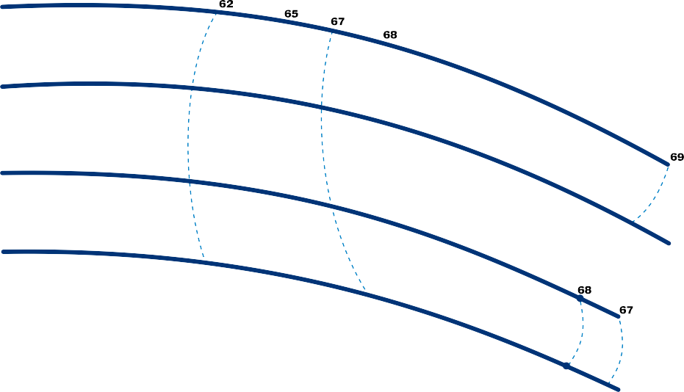

**F50/200AR**

**F50/200A**

η = **70%**

**F50/200B**

**F50/200C**

**MEI≥ 0.40**

**8** 25

**6** 20

**NPSH (metres)**

**NPSH (feet)**

**H (feet)**

**4** 15

10

**2** 5

**0** 0



**Điện hấp thụ P2 (kW)**

**P2 (HP)**

### Lưu lượng Q 

|  |  |  |  |  |  |  |  |  |  |  |  |  |  |
| --- | --- | --- | --- | --- | --- | --- | --- | --- | --- | --- | --- | --- | --- |
| **MODEL**  **Ba pha** | **POWER (P2)** | | **Q** | m³/h | 24 | 36 | 48 | 60 | 72 | 84 | 96 | 102 | 108 |
| **kW** | **HP** | l/min | **400** | **600** | **800** | **1000** | **1200** | **1400** | **1600** | **1700** | **1800** |
| **F 50/200C** | 11 | 15 | **H** metres | | 44 | 44 | 44 | 42 | 39 | 36 | 33 | 30 |  |
| **F 50/200B** | 15 | 20 | 52 | 52 | 52 | 50 | 47 | 44 | 40 | 38 |  |
| **F 50/200A** | 18.5 | 25 | 61 | 61 | 60.5 | 60 | 57 | 54 | 50 | 48 | 45 |
| **F 50/200AR** | 22 | 30 | 69 | 69 | 68.5 | 68 | 65 | 62 | 58 | 56 | 53 |

**Q** =Lưu lượng **H** = Tổng áp **HS** = Chiều sâu hút Tolerance of characteristic curves in compliance with EN ISO 9906 Grade 3B.

# F50/250

## ĐƯỜNG CONG ĐẶC TÍNH VÀ DỮ LIỆU HIỆU SUẤT 50 Hz n= 2900 min-1 HS= 0 m

##### 100

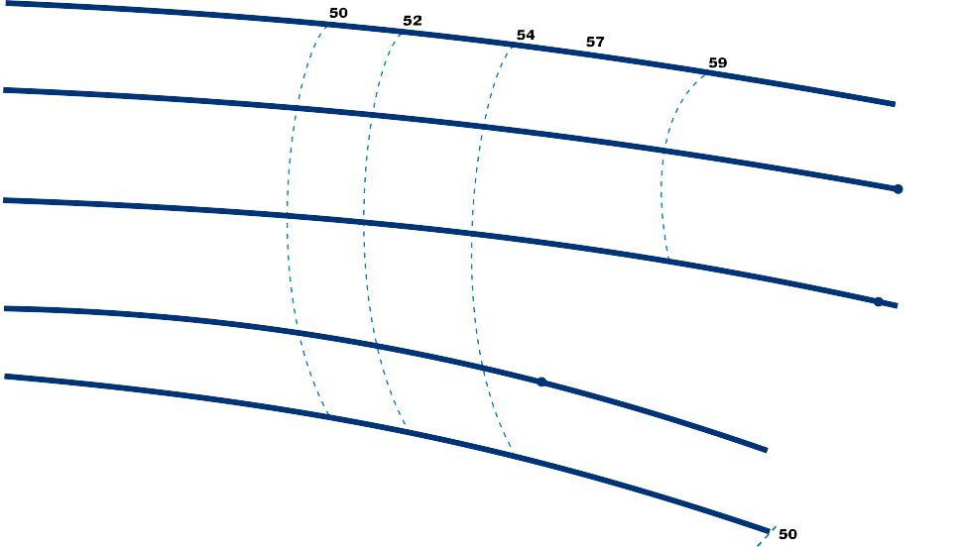

**F50/250AR**

**F50/250A**

η = **61%**

**F50/250B**

**F50/250C**

**F50/250D**

**MEI≥ 0.40**

**90**

##### 80

**70**

**Cột áp H (metres)** 

##### 60

**H (feet)**

**50**

##### 40

**30**

##### 20

**8** 25

**NPSH (metres)**

**NPSH (feet)**

**6** 20

**4** 15

10

**2** 5

**0** 0

##### 25



**Điện hấp thụ P2 (kW)**

**P2 (HP)**

**20**

##### 15

**10**

**5**



**Lưu lượng Q** 

|  |  |  |  |  |  |  |  |  |  |  |  |  |  |
| --- | --- | --- | --- | --- | --- | --- | --- | --- | --- | --- | --- | --- | --- |
| **MODEL**  **Ba pha** | **POWER (P2)** | | **Q** | m³/h | 0 | 18 | 24 | 30 | 36 | 42 | 48 | 54 | 60 |
| **kW** | **HP** | l/min | **0** | **300** | **400** | **500** | **600** | **700** | **800** | **900** | **1000** |
| **F 50/250D** | 9.2 | 12.5 | **H** metres | | 51 | 51 | 49 | 47 | 44 | 41 | 37 | 32 |  |
| **F 50/250C** | 11 | 15 | 59 | 59 | 58 | 57 | 54 | 51 | 47 | 42 |  |
| **F 50/250B** | 15 | 20 | 72 | 72 | 71 | 70 | 69 | 67 | 65 | 62 | 59 |
| **F 50/250A** | 18.5 | 25 | 85 | 85 | 84 | 83 | 82 | 80 | 78 | 76 | 73 |
| **F 50/250AR** | 22 | 30 | 95 | 95 | 94 | 93 | 92 | 90 | 88 | 86 | 83 |

**Q** =Lưu lượng **H** = Tổng áp **HS** = Chiều sâu hút Tolerance of characteristic curves in compliance with EN ISO 9906 Grade 3B.

# F65/125

## ĐƯỜNG CONG ĐẶC TÍNH VÀ DỮ LIỆU HIỆU SUẤT 50 Hz n= 2900 min-1 HS= 0 m

200 300 400 500 600

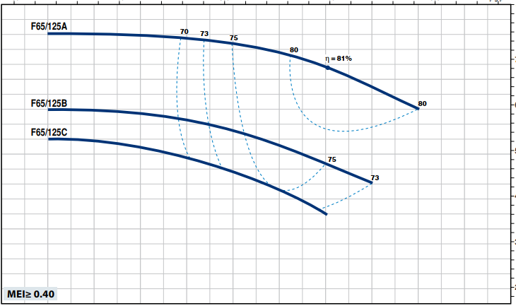100 200 300 400 500

##### 25

US g.p.m.

Imp g.p.m.

feet

**H (feet)**

70

##### 20

60

**Cột áp H (metres)** 

**15** 50

40

##### 10

30

##### 5

**6**

**NPSH (metres)**

##### 4

**2**

##### 0

**9**

**Điện hấp thụ P2 (kW)**

##### 8

**7**

##### 6

**5**

##### 4

**3**

##### 2

**400**

##### 600

**800**

##### 1000

**1200**

##### 1400

**1600**

##### 1800

**2000**

##### 2200

**2400**

20

15

**NPSH (feet)**

10

5

0

12

**A**

**B**

**C**

**P2 (HP)**

10

8

6

4

##### l/min

25 50 75 100 125 150 m³/h

**Lưu lượng Q** 

|  |  |  |  |  |  |  |  |  |  |  |  |  |  |  |
| --- | --- | --- | --- | --- | --- | --- | --- | --- | --- | --- | --- | --- | --- | --- |
| **MODEL**  **Ba pha** | **POWER (P2)** | | **Q** | m³/h | 0 | 36 | 48 | 60 | 72 | 84 | 96 | 108 | 120 | 132 |
| **kW** | **HP** | l/min | **0** | **600** | **800** | **1000** | **1200** | **1400** | **1600** | **1800** | **2000** | **2200** |
| **F 65/125C** | 4 | 5.5 | **H** metres | | 16 | 16 | 16 | 15.5 | 14.5 | 13.5 | 12.5 | 11 |  |  |
| **F 65/125B** | 5.5 | 7.5 | 18 | 18 | 18 | 18 | 17 | 16.5 | 15.5 | 14.5 | 13 |  |
| **F 65/125A** | 7.5 | 10 | 23 | 23 | 23 | 23 | 22.5 | 22.5 | 22 | 21 | 19.5 | 18 |

**Q** =Lưu lượng **H** = Tổng áp **HS** = Chiều sâu hút Tolerance of characteristic curves in compliance with EN ISO 9906 Grade 3B.

# F65/160

## ĐƯỜNG CONG ĐẶC TÍNH VÀ DỮ LIỆU HIỆU SUẤT 50 Hz n= 2900 min-1 HS= 0 m

200 300 400 500 600

100 200 300 400 500

##### 45

US g.p.m.

Imp g.p.m.

feet

140

**40** 130

120

**Cột áp H (metres)** 

##### 35

110

**H (feet)**

100

##### 30

90

##### 25

80

70

##### 20

**8**

**NPSH (metres)**

**6** 20

**NPSH (feet)**

##### 4

10

##### 2

**0** 0

##### 16

**A**

**B**

**C**

**Điện hấp thụ P2 (kW)**

**P2 (HP)**

20

##### 14

**12**

15

##### 10

**8**

##### 6

**400**

##### 600

**800**

##### 1000

**1200**

##### 1400

**1600**

##### 1800

**2000**

##### 2200

**2400**

10

##### l/min

25 50 75 100 125 150 m³/h

**Lưu lượng Q** 

|  |  |  |  |  |  |  |  |  |  |  |  |  |  |  |  |
| --- | --- | --- | --- | --- | --- | --- | --- | --- | --- | --- | --- | --- | --- | --- | --- |
| **MODEL**  **Ba pha** | **POWER (P2)** | | **Q** | m³/h | 0 | 36 | 48 | 60 | 72 | 84 | 96 | 108 | 120 | 132 | 144 |
| **kW** | **HP** | l/min | **0** | **600** | **800** | **1000** | **1200** | **1400** | **1600** | **1800** | **2000** | **2200** | **2400** |
| **F 65/160C** | 9.2 | 12.5 | **H** metres | | 32 | 32 | 32 | 32 | 32 | 30 | 29 | 27 | 25 | 22 |  |
| **F 65/160B** | 11 | 15 | 37 | 36.5 | 36.5 | 36 | 35.5 | 34 | 33 | 31 | 29 | 26 | 23 |
| **F 65/160A** | 15 | 20 | 41 | 40.5 | 40.5 | 40 | 39.5 | 39 | 37.5 | 36 | 34 | 31 | 28 |

**Q** =Lưu lượng **H** = Tổng áp **HS** = Chiều sâu hút Tolerance of characteristic curves in compliance with EN ISO 9906 Grade 3B.

# F65/200

## ĐƯỜNG CONG ĐẶC TÍNH VÀ DỮ LIỆU HIỆU SUẤT 50 Hz n= 2900 min-1 HS= 0 m

0 100 200 300 400 500 600

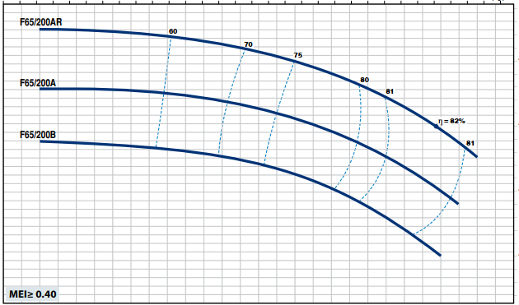0 100 200 300 400 500

##### 60

US g.p.m.

Imp g.p.m.

##### 55

**H (feet)**

175

##### 50

150

**Cột áp H (metres)** 

##### 45

**40**

125

##### 35

**30** 100

##### 25

**8** 25

**NPSH (metres)**

**NPSH (feet)**

20

##### 6

15

**4** 10

**2** 5

**0** 0

##### 25



**Điện hấp thụ P2 (kW)**

**P2 (HP)**

30

##### 20

25

**15** 20

15

##### 10

**50 200**

##### 400

**600**

##### 800

**1000**

##### 1200

**1400**

##### 1600

**1800**

##### 2000

**2200**

##### 2400

**2600**

10

##### l/min

0 25 50 75 100 125 150 m³/h

**Lưu lượng Q** 

|  |  |  |  |  |  |  |  |  |  |  |  |  |  |  |  |  |  |
| --- | --- | --- | --- | --- | --- | --- | --- | --- | --- | --- | --- | --- | --- | --- | --- | --- | --- |
| **MODEL**  **Ba pha** | **POWER (P2)** | | **Q** | m³/h | 12 | 36 | 48 | 60 | 72 | 84 | 96 | 108 | 120 | 132 | 144 | 150 | 156 |
| **kW** | **HP** | l/min | **200** | **600** | **800** | **1000** | **1200** | **1400** | **1600** | **1800** | **2000** | **2200** | **2400** | **2500** | **2600** |
| **F 65/200B** | 15 | 20 | **H** metres | | 44 | 43.5 | 43.3 | 43 | 42.5 | 41.5 | 40 | 38.5 | 36.5 | 34 | 30.5 |  |  |
| **F 65/200A** | 18.5 | 25 | 50 | 50 | 50 | 49.5 | 49 | 48 | 46.5 | 45 | 43 | 41 | 38 | 36.5 |  |
| **F 65/200AR** | 22 | 30 | 57 | 57 | 57 | 56 | 55.5 | 54.5 | 53.5 | 52 | 50 | 48 | 45.5 | 43.5 | 42 |

Q =Lưu lượng H = Tổng áp HS = Chiều sâu hút Tolerance of characteristic curves in compliance with EN ISO 9906 Grade 3B.

# F65/250

## ĐƯỜNG CONG ĐẶC TÍNH VÀ DỮ LIỆU HIỆU SUẤT 50 Hz n= 2900 min-1 HS= 0 m

##### 100

0 100 200 300 400 500 600 700

0 100 200 300 400 500 600

**F65/250A**

**58**

**65**

**70**

**F65/250B**

**72**

η = **73%**

**F65/250C**

**72**

**70**

**MEI≥ 0.40**

US g.p.m.

Imp g.p.m.

feet

300

##### 90

275

##### 80

**Cột áp H (metres)** 

**H (feet)**

250

##### 70

225

200

##### 60

**50**

##### 8

**NPSH (metres)**

**6**

##### 4

**2**

##### 0

**45**

**A**

**B**

**C**

**Điện hấp thụ P2 (kW)**

##### 40

**35**

##### 30

**25**

##### 20

**15**

##### 10

**50 500**

##### 1000

**1500**

##### 2000

**2500**

##### l/min

175

20

**NPSH (feet)**

10

0

60

**P2 (HP)**

50

40

30

20

10

0 50 100 150 m³/h

**Lưu lượng Q** 

|  |  |  |  |  |  |  |  |  |  |  |  |  |  |
| --- | --- | --- | --- | --- | --- | --- | --- | --- | --- | --- | --- | --- | --- |
| **MODEL**  **Ba pha** | **POWER (P2)** | | **Q** | m³/h | 24 | 40 | 60 | 80 | 100 | 120 | 141 | 150 | 156 |
| **kW** | **HP** | l/min | **400** | **667** | **1000** | **1333** | **1667** | **2000** | **2350** | **2500** | **2600** |
| **F 65/250C** | 30 | 40 | **H** metres | | 76 | 76 | 75.5 | 72.5 | 68 | 61.5 | 53 |  |  |
| **F 65/250B** | 37 | 50 | 87 | 87 | 86 | 84 | 80 | 74 | 66.5 | 62 |  |
| **F 65/250A** | 45 | 60 | 95 | 95 | 94 | 92 | 88 | 82.5 | 75 | 71 | 68 |

**Q** =Lưu lượng **H** = Tổng áp **HS** = Chiều sâu hút Tolerance of characteristic curves in compliance with EN ISO 9906 Grade 3B.

# F80/160

## ĐƯỜNG CONG ĐẶC TÍNH VÀ DỮ LIỆU HIỆU SUẤT 50 Hz n= 2900 min-1 HS= 0 m

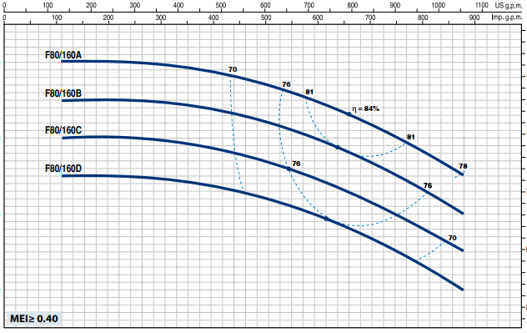

##### 45

**H (feet)**

**40**

125

##### 35

**30** 100

**Cột áp H (metres)** 

##### 25

75

##### 20

**15** 50

##### 10

25

##### 5

**NPSH (metres)**

**NPSH (feet)**



        



**Lưu lượng Q** 

**Điện hấp thụ P2 (kW)**

**P2 (HP)**

|  |  |  |  |  |  |  |  |  |  |  |  |  |  |
| --- | --- | --- | --- | --- | --- | --- | --- | --- | --- | --- | --- | --- | --- |
| **MODEL**  **Ba pha** | **POWER (P2)** | | **Q** | m³/h | 0 | 30 | 60 | 90 | 120 | 150 | 180 | 210 | 240 |
| **kW** | **HP** | l/min | **0** | **500** | **1000** | **1500** | **2000** | **2500** | **3000** | **3500** | **4000** |
| **F 80/160D** | 11 | 15 | **H** metres | | 25 | 25 | 25 | 24.5 | 23.5 | 21 | 18 | 14.5 | 10 |
| **F 80/160C** | 15 | 20 | 30 | 30 | 30 | 29.5 | 28.5 | 26 | 23 | 19.5 | 15 |
| **F 80/160B** | 18.5 | 25 | 35 | 35 | 35 | 34.5 | 33.5 | 31 | 28.5 | 24.5 | 20 |
| **F 80/160A** | 22 | 30 | 40 | 40 | 40 | 39.5 | 38.5 | 36 | 33 | 29.5 | 25 |

**Q** =Lưu lượng **H** = Tổng áp **HS** = Chiều sâu hút Tolerance of characteristic curves in compliance with EN ISO 9906 Grade 3B.

# F80/200

## ĐƯỜNG CONG ĐẶC TÍNH VÀ DỮ LIỆU HIỆU SUẤT 50 Hz n= 2900 min-1 HS= 0 m

|  |  |  |  |  |  |  |  |  |  |
| --- | --- | --- | --- | --- | --- | --- | --- | --- | --- |
|  | 0 250 |  | 500 |  | 750 |  | 1000 |  | US g.p.m. |
|  | 0 | 250 |  | 500 |  | 750 |  | 1000 | Imp g.p.m. |

t

**70**

fee

**F80/200A**

**60**

**68**

**60**

**70**

200

**72**

**F80/200B**

**75**

**79**

175

η = **82%**

**50**

**79**

150

**75**

**72**

**40**

125

**30 MEI≥ 0.40**

100

**Cột áp H (metres)** 

**10** 30

**NPSH (metres)**

##### 8

**NPSH (feet)**

**6** 20

##### 4

10

##### 2

**0** 0

##### 40

**A**

**B**

**P2 (HP)**

50

**Điện hấp thụ P2 (kW)**

**30** 40

30

##### 20

**100**

##### 500

**1000**

##### 1500

**2000**

##### 2500

**3000**

##### 3500

**4000**

##### 4500

20

##### l/min

**H (feet)**

0 50 100 150 200 250 m³/h

**Lưu lượng Q** 

|  |  |  |  |  |  |  |  |  |  |  |  |
| --- | --- | --- | --- | --- | --- | --- | --- | --- | --- | --- | --- |
| **MODEL**  **Ba pha** | **POWER (P2)** | | **Q** | m³/h | 30 | 50 | 100 | 150 | 200 | 219 | 234 |
| **kW** | **HP** | l/min | **500** | **833** | **1667** | **2500** | **3333** | **3650** | **3900** |
| **F 80/200B** | 30 | 40 | **H** metres | | 56 | 56 | 54 | 49 | 41 | 34.5 |  |
| **F 80/200A** | 37 | 50 | 62 | 62 | 61 | 57 | 50 | 45.5 | 40 |

**Q** =Lưu lượng **H** = Tổng áp **HS** = Chiều sâu hút Tolerance of characteristic curves in compliance with EN ISO 9906 Grade 3B.

# F80/250

## ĐƯỜNG CONG ĐẶC TÍNH VÀ DỮ LIỆU HIỆU SUẤT 50 Hz n= 2900 min-1 HS= 0 m

##### 100

0 250 500 750 1000

0 250 500 750 1000

**F80/250A**

**70**

**75**

**F80/250B**

**76**

η = **77%**

**75**

**71**

**69**

**MEI≥ 0.40**

US g.p.m.

Imp g.p.m.

feet

**H (feet)**

300

##### 90

275

**Cột áp H (metres)** 

##### 80

250

##### 70

225

200

##### 60

175

##### 50

**8**

**NPSH (metres)**

**NPSH (feet)**

**6** 20

##### 4

10

##### 2

**0** 0

**60** 80

**A**

**B**

**P2 (HP)**

##### 50

**Điện áp P2 (kW)**

60

##### 40

**30** 40

##### 20

**100**

##### 500

**1000**

##### 1500

**2000**

##### 2500

**3000**

##### 3500

**4000**

##### 4500

20

##### l/min

0 50 100 150 200 250 m³/h

**Lưu lượng Q** 

|  |  |  |  |  |  |  |  |  |  |  |  |
| --- | --- | --- | --- | --- | --- | --- | --- | --- | --- | --- | --- |
| **MODEL**  **Ba pha** | **POWER (P2)** | | **Q** | m³/h | 36 | 50 | 100 | 150 | 200 | 216 | 234 |
| **kW** | **HP** | l/min | **600** | **833** | **1667** | **2500** | **3333** | **3600** | **3900** |
| **F 80/250B** | 45 | 60 | **H** metres | | 77 | 77.5 | 76 | 70.5 | 58.5 | 54 |  |
| **F 80/250A** | 55 | 75 | 88.5 | 89.5 | 89 | 83 | 72 | 68 | 60 |

**Q =**Lưu lượng **H =** Tổng áp **HS =** Chiều sâu hút Tolerance of characteristic curves in compliance with EN ISO 9906 Grade 3B.

# F100/160

## ĐƯỜNG CONG ĐẶC TÍNH VÀ DỮ LIỆU HIỆU SUẤT 50 Hz n= 2900 min-1 HS= 0 m

0 500 1000

0 500 1000

##### 40

**F100/160A**

**60**

**F100/160B**

**67**

**72**

**75**

**77**

**F100/160C**

**79**

η = **80%**

**79**

**79**

**77**

**75**

**72**

**67**

**MEI≥ 0.40**

US g.p.m.

Imp g.p.m.

feet 125

##### 35

**30** 100

**Cột áp H (metres)** 

##### 25

**H (feet)**

75

##### 20

**15** 50

##### 10

**10**

30

**NPSH (metres)**

**8** 25

**NPSH (feet)**

**6** 20

15

##### 4

10

##### 2

**25**

**P2 (HP)**

**A**

**B**

**C**

30

**Điện hấp thụP2 (kW)**

##### 20

25

**15** 20

##### 100

**500**

##### 1000

**1500**

##### 2000

**2500**

##### 3000

**3500**

##### 4000

**4500**

##### 5000

**5500**

15

##### l/min

0 50 100 150 200 250 300 m³/h

**Lưu lượng Q** 

|  |  |  |  |  |  |  |  |  |  |  |  |  |  |  |  |
| --- | --- | --- | --- | --- | --- | --- | --- | --- | --- | --- | --- | --- | --- | --- | --- |
| **MODEL**  **Ba pha** | **POWER (P2)** | | **Q** | m³/h | 60 | 90 | 120 | 150 | 180 | 210 | 240 | 270 | 300 | 312 | 330 |
| **kW** | **HP** | l/min | **1000** | **1500** | **2000** | **2500** | **3000** | **3500** | **4000** | **4500** | **5000** | **5200** | **5500** |
| **F 100/160C** | 15 | 20 | **H** metres | | 30 | 29 | 27.5 | 25.5 | 23.5 | 21 | 18.5 | 15.5 | 12 |  |  |
| **F 100/160B** | 18.5 | 25 | 34 | 33 | 31.5 | 30 | 28 | 25.5 | 22.5 | 19.5 | 16 | 14.5 |  |
| **F 100/160A** | 22 | 30 | 38 | 37 | 36 | 34 | 32 | 30 | 27.5 | 24.5 | 21 | 20 | 17.5 |

**Q** =Lưu lượng **H** = Tổng áp **HS** = Chiều sâu hút Tolerance of characteristic curves in compliance with EN ISO 9906 Grade 3B.

# F100/200

## ĐƯỜNG CONG ĐẶC TÍNH VÀ DỮ LIỆU HIỆU SUẤT 50 Hz n= 2900 min-1 HS= 0 m

0 250 500 750 1000 1250

0 250 500 750 1000

##### 70

US g.p.m.

Imp g.p.m.

feet

**H (feet)**

##### 65

200

##### 60

**55**

**Cột áp H (metres)** 

175

##### 50

**45** 150

##### 40

125

##### 35

**30** 100

##### 25

**10** 30

**NPSH (metres)**

**NPSH (feet)**

##### 8

**6** 20

##### 4

10

##### 2

**0** 0

##### 50

**A**

**B**

**C**

**Điện hấp thụ P2 (kW)**

**P2 (HP)**

60

##### 40

50

**30** 40

##### 20

**100**

0

##### 500

**1000**

50

##### 1500

100

##### 2000

**2500**

150

##### 3000

200

##### 3500

**4000**

250

##### 4500

**5000**

300

##### 5500

30

20

##### l/min

m³/h

**Lưu lượng Q** 

|  |  |  |  |  |  |  |  |  |  |  |  |  |  |  |  |
| --- | --- | --- | --- | --- | --- | --- | --- | --- | --- | --- | --- | --- | --- | --- | --- |
| **MODEL**  **Ba pha** | **POWER (P2)** | | **Q** | m³/h | 0 | 50 | 96 | 150 | 180 | 210 | 240 | 279 | 294 | 300 | 315 |
| **kW** | **HP** | l/min | **0** | **833** | **1600** | **2500** | **3000** | **3500** | **4000** | **4650** | **4900** | **5000** | **5250** |
| **F 100/200C** | 30 | 40 | **H** metres | | 51 | 51 | 50 | 47 | 44 | 40.5 | 35.5 | 28 |  |  |  |
| **F 100/200B** | 37 | 50 | 57 | 57 | 56 | 53 | 50.5 | 47 | 42.5 | 36 | 33 |  |  |
| **F 100/200A** | 45 | 60 | 63 | 63 | 62.5 | 60 | 58 | 55 | 51.5 | 45 | 42.5 | 41.5 | 38 |

**Q** =Lưu lượng **H** = Tổng áp **HS** = Chiều sâu hút Tolerance of characteristic curves in compliance with EN ISO 9906 Grade 3B.

# F100/250

## ĐƯỜNG CONG ĐẶC TÍNH VÀ DỮ LIỆU HIỆU SUẤT 50 Hz n= 2900 min-1 HS= 0 m

##### 100

0 250 500 750 1000 1250 1500

0 250 500 750 1000 1250

**F100/250A**

**60**

**67**

**72**

**75**

**77**

**79**

**F100/250B**

η = **80%**

**79**

**77**

**79.5%**

**75**

**72**

**MEI≥ 0.40**

US g.p.m.

Imp g.p.m.

feet

300

##### 90

275

##### 80

**Cột áp H (metres)** 

250

##### 70

**H (feet)**

225

**60** 200

175

##### 50

150

##### 40

**10** 30

**NPSH (metres)**

##### 8

**NPSH (feet)**

**6** 20

##### 4

10

##### 2

**0** 0

##### 80

**A**

**B**

**P2 (HP)**

100

**Điện hấp thụ P2 (kW)**

##### 70

**60** 80

##### 50

60

##### 40

**30**

##### 20

**0 500**

##### 1000

**1500**

##### 2000

**2500**

##### 3000

**3500**

##### 4000

**4500**

##### 5000

**5500**

##### 6000

40

##### l/min

0 50 100 150 200 250 300 350 m³/h

**Lưu lượng Q** 

|  |  |  |  |  |  |  |  |  |  |  |  |  |  |
| --- | --- | --- | --- | --- | --- | --- | --- | --- | --- | --- | --- | --- | --- |
| **MODEL**  **Ba pha** | **POWER (P2)** | | **Q** | m³/h | 48 | 96 | 150 | 180 | 210 | 240 | 300 | 309 | 345 |
| **kW** | **HP** | l/min | **800** | **1600** | **2500** | **3000** | **3500** | **4000** | **5000** | **5150** | **5750** |
| **F 100/250B** | 55 | 75 | **H** metres | | 75 | 75 | 73 | 71 | 68 | 64 | 50.5 | 48 |  |
| **F 100/250A** | 75 | 100 | 89 | 89 | 87.5 | 86 | 83.5 | 80.5 | 70 | 68 | 58 |

**Q** =Lưu lượng **H** = Tổng áp **HS** = Chiều sâu hút Tolerance of characteristic curves in compliance with EN ISO 9906 Grade 3B.

# F

## POS. THÀNH PHẦN ĐẶC ĐIỂM

#### **1 THÂN BƠM** Gang hoàn chỉnh với mặt bích và cổng phân phối

**2a TẤM THÂN** Gang đối với F32/160, F32/200, F40/125, F40/160, F40/200, F50/125, F50/160, F65/125



#### **2b KHUNG ĐỘNG CƠ** Gang đối với F32/250, F40/250, F50/200, F50/250, F65/160, F65/200, F65/250,

F80/160, F80/200, F80/250, F100/160, F100/200, F100/250



#### **3 CÁNH** Brass for F32/160, F32/200, F40/125, F40/160, F40/200, F50/125, F50/160

Gang đối với F32/250, F40/250, F50/200, F50/250, F65/125, F65/160, F65/200, F65/250, F80/160, F80/200, F80/250, F100/160, F100/200, F100/250



1. **TRỤC ĐỘNG CƠ** Thép không gỉ AISI 431
2. **SEAL CƠ KHÍ *Bơm Seal Trục*** *Vật liệu*

***Model Model Đường kiính*** *Vòng cố định Vòng quay Chất đàn hồi*

#### F32/160, F40/125, F40/160, F50/125 **FN-20 Ø 20** mm Than chì Gốm sứ NBR F32/200, F40/200, F50/160, F65/125 **FN-24 Ø 24** mm Than chì Gốm sứ NBR F50/200, F65/160, F65/200, F80/160,

#### F100/160 **FN-32 NU Ø 32** mm Than chì Gốm sứ NBR F32/250, F40/250, F50/250 **FN-38 Ø 38** mm Than chì Gốm sứ NBR F65/250, F80/200, F80/250B, F100/200 **FN-40 NU Ø 40** mm Than chì Gốm sứ NBR

#### F80/250A, F100/250 **FH-45 NU Ø 45** mm Than chì Gốm sứ NBR

1. **VÒNG BI *Bơm Model Bơm Model***

|  |  |  |  |  |  |  |
| --- | --- | --- | --- | --- | --- | --- |
| F32/160C  F32/160B  F40/125 | F40/160C  F50/125C | **6206 ZZ-C3 / 6204 ZZ** | F32/250 | F50/200 | **6310 ZZ-C3 / 6308 ZZ-C3** | |
| F40/250 | F65/160 |
| F50/250 | F80/160 |
| Fm32/160B | F32/160A | **6206 ZZ-C3 / 6205 ZZ** | F65/200 | F100/160 |
| Fm40/160C | F40/160B | F65/250 | F80/200 | **6312 ZZ-C3 / 6212 ZZ-C3** | |
| Fm50/125C | F50/125B | F80/250B | F100/200 |
| F40/160A |  | **6306 ZZ-C3 / 6206 ZZ-C3** | F80/250A |  | **6314 ZZ-C3 / 6313 ZZ-C3** | |
| F50/125A |  | F100/250 |  |
| F32/200 | F40/200 | **6307 ZZ-C3 / 6206 ZZ-C3** |  |  |  |  |
| F50/160 | F65/125 |  |  |  |  |



1. **TỤ ĐIỆN *Bơm Điện dung***

***Một pha (230V hoặc 240V)***

#### Fm32/160C **45 $μF$** - 450VL

#### Fm32/160B **70 $μF$** – 450VL

#### Fm40/125C **31.5 $μF$** - 450VL

#### Fm440/125B **45 $μF$** – 450VL

#### Fm40/160C **70 $μF$** – 450VL

#### Fm50/125C **70 $μF$** – 450VL

#### 

1. **ĐỘNG CƠ ĐIỆN Fm**: một pha 230 V - 50 Hz với bộ bảo vệ quá tải nhiệt được tích hợp vào cuộn dây (lên đến 1,5 kW)

### F: ba pha 230/400 V - 50 Hz đến 4 kW 400/690 V - 50 Hz từ 5,5 đến 75 kW

➠ **Máy bơm ba pha được lắp động cơ hiệu suất cao ở cấp IE3 (IEC 60034-30-1)**

– Cách nhiệt: lớp F

– Cấp bảo vệ: IP 55

**Một pha Ba pha**

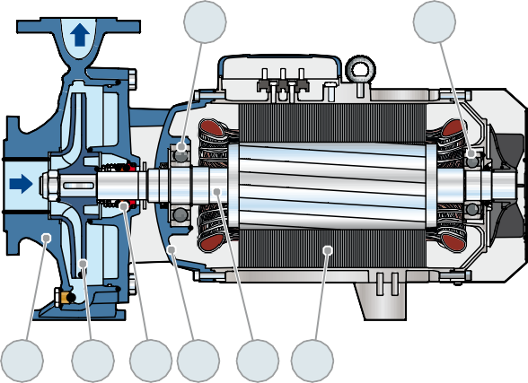

**6**

**6**

**1**

**3**

**5 2b 4 8**

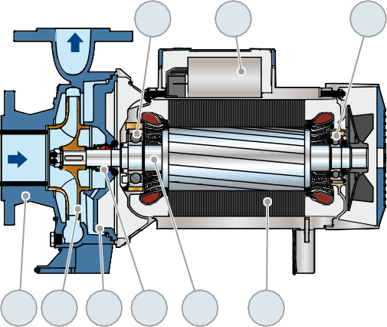

**6**

**7**

**6**

**1 3 2a 5**

**4**

**8**





**DÒNG ĐIỆN**

|  |  |  |
| --- | --- | --- |
| **MODEL**  **Một pha** | **VOLTAGE** | |
| 230 V | 240 V |
| **Fm 32/160C** | **11.0** A | **10.0** A |
| **Fm 32/160B** | **15.0** A | **13.8** A |
| **Fm 40/160C** | **15.0** A | **14.4** A |
| **Fm 50/125C** | **15.0** A | **14.4** A |

|  |  |  |  |
| --- | --- | --- | --- |
| **MODEL**  **Ba pha** | **VOLTAGE** | | |
| 230–240 V | 400–415 V | 690–720 V |
| **F 32/160C** | **7.5** A | **4.3** A | **2.5** A |
| **F 32/160B** | **8.65** A | **5.0** A | **2.9** A |
| **F 32/160A** | **12.6** A | **7.3** A | **4.1** A |
| **F 32/200C** | **17.9** A | **10.3** A | **6.0** A |
| **F 32/200B** | **–** | **11.7** A | **6.8** A |
| **F 32/200A** | **–** | **14.9** A | **8.6** A |
| **F 32/200BH** | **12.6** A | **7.3** A | **4.2** A |
| **F 32/200AH** | **15.4** A | **8.9** A | **5.1** A |
| **F 32/250C** | **–** | **18.5** A | **10.7** A |
| **F 32/250B** | **–** | **22.0** A | **12.7** A |
| **F 32/250A** | **–** | **25.0** A | **14.5** A |
| **F 40/125C** | **5.2** A | **3.0** A | **1.7** A |
| **F 40/125B** | **7.7** A | **4.5** A | **2.6** A |
| **F 40/125A** | **9.0** A | **5.2** A | **3.0** A |
| **F 40/160C** | **9.9** A | **5.7** A | **3.3** A |
| **F 40/160B** | **12.0** A | **6.9** A | **4.0** A |
| **F 40/160A** | **17.2** A | **9.9** A | **5.6** A |
| **F 40/200B** | **–** | **12.6** A | **7.3** A |
| **F 40/200A** | **–** | **15.6** A | **9.0** A |
| **F 40/250C** | **–** | **21.0** A | **12.1** A |
| **F 40/250B** | **–** | **23.5** A | **13.6** A |
| **F 40/250A** | **–** | **30.5** A | **17.6** A |
| **F 50/125C** | **9.4** A | **5.4** A | **3.2** A |
| **F 50/125B** | **12.0** A | **6.9** A | **4.0** A |
| **F 50/125A** | **16.3** A | **9.4** A | **5.4** A |
| **F 50/160C** | **15.8** A | **9.1** A | **5.3** A |
| **F 50/160B** | **–** | **12.3** A | **7.1** A |
| **F 50/160A** | **–** | **15.5** A | **8.9** A |
| **F 50/200C** | **–** | **23.0** A | **13.3** A |
| **F 50/200B** | **–** | **29.5** A | **17.0** A |
| **F 50/200A** | **–** | **34.5** A | **20.0** A |
| **F 50/200AR** | **–** | **41.5** A | **24.0** A |

|  |  |  |  |
| --- | --- | --- | --- |
| **MODEL**  **Ba pha** | **VOLTAGE** | | |
| 230–240 V | 400–415 V | 690–720 V |
| **F 50/250D** | **–** | **19.0** A | **11.0** A |
| **F 50/250C** | **–** | **21.0** A | **12.0** A |
| **F 50/250B** | **–** | **27.0** A | **15.6** A |
| **F 50/250A** | **–** | **34.0** A | **19.6** A |
| **F 50/250AR** | **–** | **41.0** A | **24.0** A |
| **F 65/125C** | **17.5** A | **10.0** A | **5.8** A |
| **F 65/125B** | **–** | **12.0** A | **7.0** A |
| **F 65/125A** | **–** | **16.5** A | **9.5** A |
| **F 65/160C** | **–** | **19.0** A | **11.0** A |
| **F 65/160B** | **–** | **23.0** A | **13.5** A |
| **F 65/160A** | **–** | **27.5** A | **16.0** A |
| **F 65/200B** | **–** | **30.0** A | **17.3** A |
| **F 65/200A** | **–** | **34.0** A | **19.5** A |
| **F 65/200AR** | **–** | **41.0** A | **24.0** A |
| **F 65/250C** | **–** | **53.0** A | **31.0** A |
| **F 65/250B** | **–** | **65.0** A | **38.0** A |
| **F 65/250A** | **–** | **79.0** A | **46.0** A |
| **F 80/160D** | **–** | **22.0** A | **13.0** A |
| **F 80/160C** | **–** | **29.0** A | **17.0** A |
| **F 80/160B** | **–** | **34.5** A | **20.0** A |
| **F 80/160A** | **–** | **39.0** A | **22.5** A |
| **F 80/200B** | **–** | **53.0** A | **31.0** A |
| **F 80/200A** | **–** | **65.0** A | **38.0** A |
| **F 80/250B** | **–** | **79.0** A | **46.0** A |
| **F 80/250A** | **–** | **98.0** A | **57.0** A |
| **F 100/160C** | **–** | **27.5** A | **16.0** A |
| **F 100/160B** | **–** | **32.5** A | **18.8** A |
| **F 100/160A** | **–** | **39.8** A | **23.0** A |
| **F 100/200C** | **–** | **53.0** A | **31.0** A |
| **F 100/200B** | **–** | **65.0** A | **38.0** A |
| **F 100/200A** | **–** | **79.0** A | **46.0** A |
| **F 100/250B** | **–** | **98.0** A | **57.0** A |
| **F 100/250A** | **–** | **126.0** A | **73.0** A |

# F

## KÍCH THƯỚC – TRỌNG LƯỢNG

###### f t

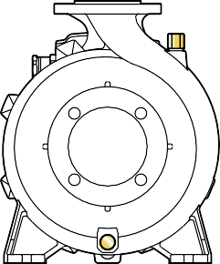

**s**

**n2**

**n1**

**a**

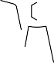

###### DN2

**m2 m1**

**DN1**

**h1 h2**

**h3**

|  |  |  |  |  |  |  |  |  |  |  |  |  |  |  |  |  |
| --- | --- | --- | --- | --- | --- | --- | --- | --- | --- | --- | --- | --- | --- | --- | --- | --- |
| **MODEL** | | **KÍCH THƯỚC mm** | | | | | | | | | | | | | **kg** | |
| **Một pha** | **Ba pha** | **DN1** | **DN2** | a | f | h1 | h2 | h3 | t | n1 | n2 | m1 | m2 | s | 1~ | 3~ |
| **Fm 32/160C** | **F 32/160C** | **50** | **32** | 80 | 419 | 132 | 160 | 292 | 240 | 245 | 190 | 100 | 70 | 14 | **32.6** | **32.3** |
| **Fm 32/160B** | **F 32/160B** | 448/432 | **42.3** | **35.2** |
| **–** | **F 32/160A** | 448 | **–** | **38.7** |
| **–** | **F 32/200C** | 469 | 160 | 180 | 340 | 273 | 95 | **–** | **46.3** |
| **–** | **F 32/200B** | 515 | **–** | **51.8** |
| **–** | **F 32/200A** | **–** | **56.9** |
| **–** | **F 32/200BH** | 469 | **–** | **42.0** |
| **–** | **F 32/200AH** | **–** | **45.8** |
| **–** | **F 32/250C** | 100 | 606 | 180 | 225 | 405 | 325 | 320 | 250 | 125 | 95 | – | **105.5** |
| **–** | **F 32/250B** | – | **103.2** |
| **–** | **F 32/250A** | 701 | – | **121.0** |
| **Fm 40/125C** | **F 40/125C** | **65** | **40** | 80 | 421 | 112 | 140 | 252 | 244 | 210 | 160 | 100 | 70 | **31.5** | **29.9** |
| **Fm 40/125B** | **F 40/125B** | **33.0** | **32.4** |
| **–** | **F 40/125A** | 441 | – | **32.6** |
| **Fm 40/160C** | **F 40/160C** | 439 | 132 | 160 | 292 | 241 | 240 | 190 | **38.3** | **33.4** |
| **–** | **F 40/160B** | 448 | **–** | **38.9** |
| **–** | **F 40/160A** | 465 | **–** | **43.6** |
| **–** | **F 40/200B** | 100 | 535 | 160 | 180 | 340 | 277 | 265 | 212 | **–** | **53.0** |
| **–** | **F 40/200A** | **–** | **59.0** |
| **–** | **F 40/250C** | 606 | 180 | 225 | 405 | 329 | 320 | 250 | 125 | 95 | **–** | **104.0** |
| **–** | **F 40/250B** | **–** | **104.0** |
| **–** | **F 40/250A** | 701 | **–** | **120.0** |
| **Fm 50/125C** | **F 50/125C** | **65** | **50** | 465/451 | 132 | 160 | 292 | 242 | 240 | 190 | 100 | 70 | **36.8** | **35.1** |
| **–** | **F 50/125B** | 465 | **–** | **38.5** |
| **–** | **F 50/125A** | 484 | **–** | **42.8** |
| **–** | **F 50/160C** | 489 | 160 | 180 | 340 | 273 | 265 | 212 | **–** | **47.3** |
| **–** | **F 50/160B** | 535 | **–** | **52.8** |
| **–** | **F 50/160A** | **–** | **57.6** |
| **–** | **F 50/200C** | 616 | 200 | 360 | 316.5 | **–** | **100.0** |
| **–** | **F 50/200B** | 711 | **–** | **115.0** |
| **–** | **F 50/200A** | **–** | **127.2** |
| **–** | **F 50/200AR** | 743 | **–** | **141.0** |
| **–** | **F 50/250D** | 605 | 180 | 225 | 405 | 333 | 320 | 250 | 125 | 95 | **–** | **104.2** |
| **–** | **F 50/250C** | **–** | **105.0** |
| **–** | **F 50/250B** | 701 | **–** | **121.0** |
| **–** | **F 50/250A** | **–** | **134.2** |
| **–** | **F 50/250AR** | 733 | **–** | **147.0** |
| **–** | **F 65/125C** | **80** | **65** | 511 | 160 | 180 | 340 | 292 | 280 | 212 | **–** | **53.2** |
| **–** | **F 65/125B** | 557 | **–** | **58.3** |
| **–** | **F 65/125A** | **–** | **63.0** |
| **–** | **F 65/160C** | 620 | 200 | 360 | 295 | **–** | **98.5** |
| **–** | **F 65/160B** | **–** | **100.2** |
| **–** | **F 65/160A** | 716 | **–** | **114.0** |
| **–** | **F 65/200B** | 718 | 180 | 225 | 405 | 336 | 320 | 250 | **–** | **119.3** |
| **–** | **F 65/200A** | **–** | **132.1** |
| **–** | **F 65/200AR** | 751 | **–** | **145.3** |
| **–** | **F 80/160D** | **100** | **80** | 125 | 652 | 330 | **–** | **103.1** |
| **–** | **F 80/160C** | 747 | **–** | **120.0** |
| **–** | **F 80/160B** | **–** | **133.8** |
| **–** | **F 80/160A** | 779 | **–** | **144.0** |
| **–** | **F 100/160C** | **125** | **100** | 760 | 200 | 280 | 480 | 382 | 360 | 280 | 160 | 120 | 18 | **–** | **141.2** |
| **–** | **F 100/160B** | **–** | **150.3** |
| **–** | **F 100/160A** | 790 | **–** | **164.0** |



**c**

## KÍCH THƯỚC – TRỌNG LƯỢNG

**t**

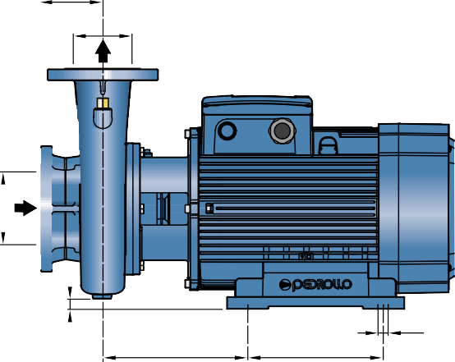

**f**

**a**

**DN2**

**s**

**w**

**m**

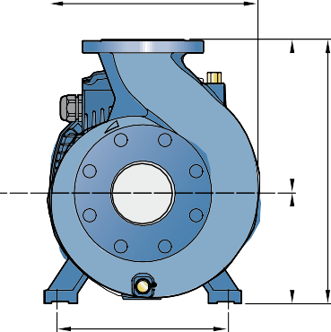

**n2**

**n1**

**DN1**

**h1 h2**

**h3**

|  |  |  |  |  |  |  |  |  |  |  |  |  |  |  |  |
| --- | --- | --- | --- | --- | --- | --- | --- | --- | --- | --- | --- | --- | --- | --- | --- |
| **MODEL**  **Ba pha** | **KÍCH THƯỚC mm** | | | | | | | | | | | | | | **kg**  3~ |
| **DN1** | **DN2** | a | f | h1 | h2 | h3 | c | t | n1 | n2 | w | m | s |
| **F 65/250C** | **80** | **65** | 100 | 796 | 201 | 250 | 451 | 16 | 363 | 360 | 318 | 269.5 | 305 | 18.5 | **208.0** |
| **F 65/250B** | 847 | **226.0** |
| **F 65/250A** | 847 | **246.2** |
| **F 80/200B** | **100** | **80** | 125 | 824 | 450 | 26 | 360 | **197.4** |
| **F 80/200A** | 875 | **223.0** |
| **F 80/250B** | 872 | 280 | 480 | 12 | 380 | **240.0** |
| **F 80/250A** | 1015 | 250 | 620 | 55 | 490 | 490 | 400 | 294 | 350 | 24 | **547.0** |
| **F 100/200C** | **125** | **100** | 826 | 201 | 280 | 481 | 0 | 391 | 360 | 318 | 271 | 305 | 18.5 | **214.4** |
| **F 100/200B** | 875 | **234.2** |
| **F 100/200A** | 877 | **232.8** |
| **F 100/250B** | 140 | 1060 | 250 | 280 | 620 | 40 | 485 | 485 | 406 | 313 | 350 | 24 | **551.2** |
| **F 100/250A** | **544.3** |

## CỔNG MẶT BÍCH MẶT BÍCH ĐỐI

(CÓ THỂ ĐẶT RIÊNG LẺ)

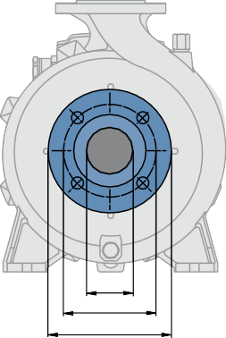

**DN K D**

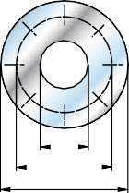

**F**

**K D**

|  |  |  |  |  |  |
| --- | --- | --- | --- | --- | --- |
| **DN MẶT BÍCH**  **mm** | **F**  **MẶT BÍCH ĐỐI** | **D**  **mm** | **K**  **mm** | **HOLES** | |
| **N°** | **Ø (mm)** |
| 32 | **1¼"** | 140 | 100 | 4 | 18 |
| 40 | **1½"** | 150 | 110 |
| 50 | **2"** | 165 | 125 |
| 65 | **2½"** | 185 | 145 |
| 80 | **3"** | 200 | 160 | 8 |
| 100 | **4"** | 220 | 180 |
| 125 | **5"** | 250 | 210 |

|  |  |  |  |  |
| --- | --- | --- | --- | --- |
| **DN MẶT BÍCH**  **mm** | **D**  **mm** | **K**  **mm** | **HOLES** | |
| **N°** | **Ø (mm)** |
| **32** | 140 | 100 | 4 | 18 |
| **40** | 150 | 110 |
| **50** | 165 | 125 |
| **65** | 185 | 145 |
| **80** | 200 | 160 | 8 |
| **100** | 220 | 180 |
| **125** | 250 | 210 |

***Tài liệu này chỉ có tính tham khảo mà không có bất kỳ sự ràng buộc nào với THUCO. Vui lòng liên hệ với chúng tôi để được giải thích chi tiết các thông tin bạn quan tâm!***

**Công ty TNHH Sản Xuất Công Nghiệp Tiến Hưng**

Địa chỉ: 62D/11 Nguyên Hồng, Phường 11 Bình Thạnh, Tp.Hồ Chí Minh, Việt Nam

 033.816.8689

[tienhung@thucorp.com](mailto:tienhung@thucorp.com%20) -  [thucorp.com](mailto:sales@pedrollo.com)